ENTERPRISE HR COPILOT
An Agentic RAG Assistant for HR Policy and Employee Support Built with LangGraph, Gemini, Pinecone and Tavily

Project Description:
Enterprise HR Copilot is an AI-powered assistant that answers employee questions about company HR policies using an Agentic RAG (Retrieval-Augmented Generation) workflow. Instead of sending every question to a language model, the system decides how the question should be handled. Greetings are answered directly, while HR questions are searched in the company's private knowledge base stored in Pinecone, and the retrieved evidence is graded by Gemini before generating an answer.When private evidence is weak, the agent falls back to Tavily web search and grades the results. If evidence is still insufficient, the query is rewritten and retried once, after which the agent returns an "insufficient evidence" message instead of guessing. Every answer includes its source, citations and execution trace, and every request is recorded in an SQLite audit database.HR administrators can upload PDF, TXT, Markdown or DOCX documents through a protected endpoint, where files are chunked, embedded and indexed. The application uses FastAPI, an HTML, CSS and JavaScript interface, and Docker for deployment on a DigitalOcean droplet. This solution provides trustworthy, transparent HR support, reduces repetitive queries and delivers fast, reliable answers.

Scenarios
1. Scenario – Private Knowledge Base Answer: Retrieves relevant HR handbook information using Pinecone and generates accurate, source-cited answers with Gemini.
2. Scenario – Company Policy Question: Answers employee questions about remote work and other company policies using internal documents without unnecessary web searches.
3. Scenario – External Information Fallback: Uses Tavily web search when internal knowledge is insufficient and provides external information with an HR validation notice.
4. Scenario – Query Rewrite and Retry: Rewrites vague employee questions with relevant HR keywords and retries knowledge base retrieval once to improve results.
5. Scenario – Insufficient Evidence Handling: Avoids generating unsupported answers and directs employees to contact the HR team when reliable information is unavailable.
6. Scenario – Admin Document Ingestion: Allows administrators to upload HR policy documents, validate files, split content into chunks, generate embeddings, and store them in Pinecone.
7. Scenario – API Access and Audit: Provides answers, citations, rewritten queries, and execution traces through the FastAPI endpoint while maintaining audit logs in SQLite

Technical Architecture:
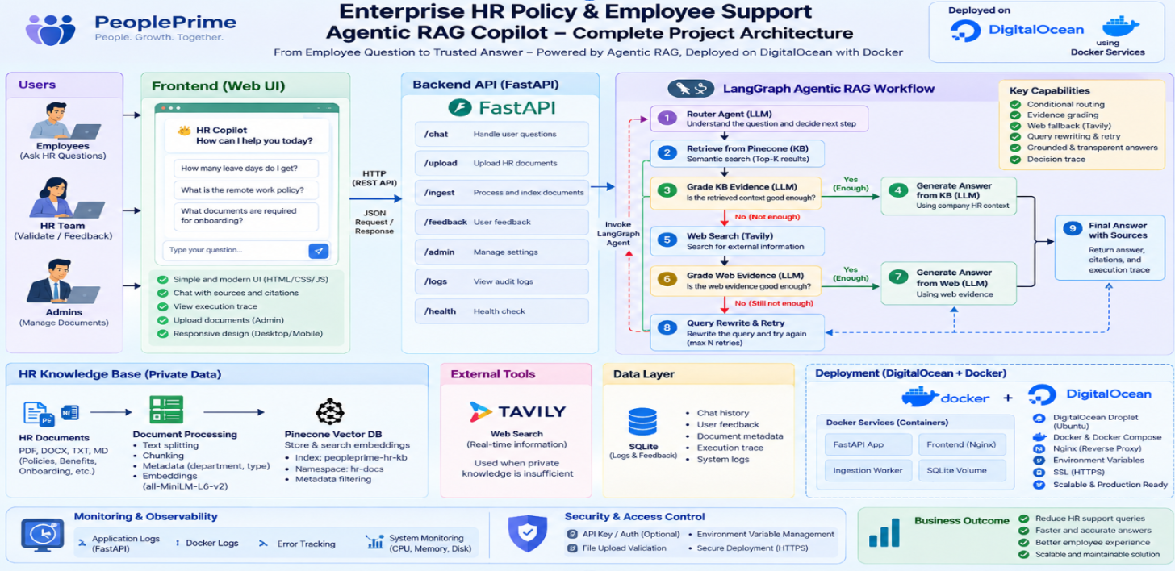
The architecture shows employees, HR staff and administrators using a web interface that talks to a FastAPI backend over REST. The backend invokes a LangGraph Agentic RAG workflow that combines a private Pinecone knowledge base, Tavily web search and Gemini for routing, grading, rewriting and answer generation, while SQLite stores audit logs and Docker on DigitalOcean provides deployment.

Prerequisites:
- Python 3.11 — core language runtime (the Docker image uses python:3.11-slim)
- Virtual Environment (venv) — isolated Python environments, built into Python
- pip — Python package installer
- VS Code — code editor used for development
- Git — version control and cloning the repository
- Docker — containerization platform used for packaging and deployment
- Google AI Studio — to create the Gemini API key
- Pinecone — serverless vector database account and API key
- Tavily — web search API key for the fallback search
- SQLite — audit database (bundled with Python, no installation needed)
- curl — command-line HTTP client, useful for testing the API
- DigitalOcean — optional, cloud droplet for deployment

Project Workflow:
Activity 1: Environment Setup and Configuration
- Activity 1.1: Configure the Python development environment.
- Activity 1.2: Create the project structure.
- Activity 1.3: Install project dependencies.
- Activity 1.4: Configure API credentials in .env.
- Activity 1.5: Centralise application settings and logging.
Activity 2: Knowledge Base and Document Ingestion
- Activity 2.1: Prepare the sample HR knowledge base.
- Activity 2.2: Load PDF, TXT, Markdown and DOCX documents.
- Activity 2.3: Split documents into chunks.
- Activity 2.4: Configure embeddings and the Pinecone index.
- Activity 2.5: Index the knowledge base and verify.
Activity 3: AI and LLM Integration
- Activity 3.1: Define the structured decision schemas.
- Activity 3.2: Define the shared agent state.
- Activity 3.3: Configure the Gemini LLM client.
- Activity 3.4: Configure the Tavily web search tool.
- Activity 3.5: Construct the router, grader and rewrite prompts.
- Activity 3.6: Construct the answer generation prompts.
Activity 4: Agentic RAG Workflow with LangGraph
- Activity 4.1: Implement the trace helper and KB retrieval node.
- Activity 4.2: Implement the web search node.
- Activity 4.3: Implement the conditional routing functions.
- Activity 4.4: Implement the insufficient-evidence node.
- Activity 4.5: Build and compile the LangGraph graph.
- Activity 4.6: Expose the workflow through ask().
Activity 5: FastAPI Backend and Audit Logging
- Activity 5.1: Initialise the FastAPI application.
- Activity 5.2: Define the request schema and validation.
- Activity 5.3: Implement the health and chat endpoints.
- Activity 5.4: Implement the protected ingestion endpoint.
- Activity 5.5: Implement SQLite audit logging.
- Activity 5.6: Configure local execution with run.py.
Activity 6: User Interface Development and Walkthrough
- Activity 6.1: Build the page layout (index.html).
- Activity 6.2: Style the interface (style.css).
- Activity 6.3: Connect the interface to /api/chat.
- Activity 6.4: Implement the document upload modal.
- Activity 6.5: Walk through the user interface.
- Activity 6.6: Walk through the question scenarios.
Activity 7: Testing, Containerisation and Deployment
- Activity 7.1: Containerise the application with Docker.
- Activity 7.2: Exclude unnecessary files with .dockerignore.
- Activity 7.3: Build and run the container.
- Activity 7.4: Perform functional and API testing.
- Activity 7.5: Verify chunking and server startup.
- Activity 7.6: Deploy on a DigitalOcean droplet.

Milestone 1 — Environment Setup and Configuration
Established the Python development environment, created the project structure, installed the LangGraph, LangChain, Pinecone, Gemini, Tavily and FastAPI dependencies, and configured the API credentials and centralised application settings.

Activity 1.1: Configure the Python Development Environment
The Python development environment was configured with Python 3.11, the same version used by the Docker image. A dedicated virtual environment named venv was created in the project root and activated so that all project packages are installed in isolation from the system Python. VS Code was then pointed at this interpreter, and the installation was verified using python --version and pip --version.

Activity 1.2: Create the Project Structure
The helper script create_project.py creates the complete folder layout in one run: app/api, app/core, app/rag, app/services, data, templates, static, uploads and tests, along with the starting files app/main.py, ingest_sample_kb.py, requirements.txt, run.py and .env. Using mkdir(parents=True, exist_ok=True) and touch(exist_ok=True) makes the script safe to run repeatedly.
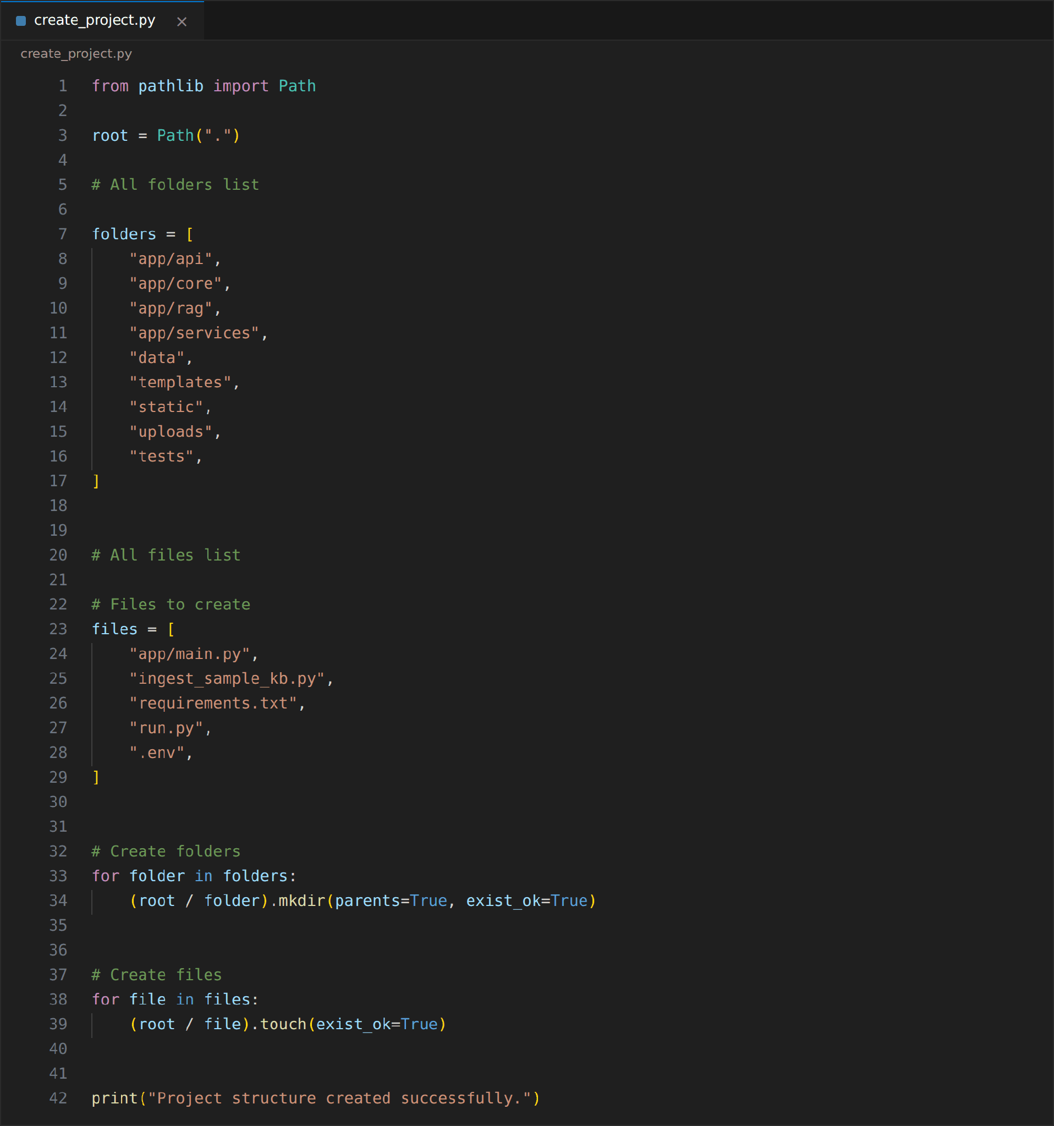
The finished project follows a layered structure that keeps each responsibility in its own package: core for settings, rag for the LangGraph workflow and vector store, services for ingestion and audit logging, and api for the HTTP routes.
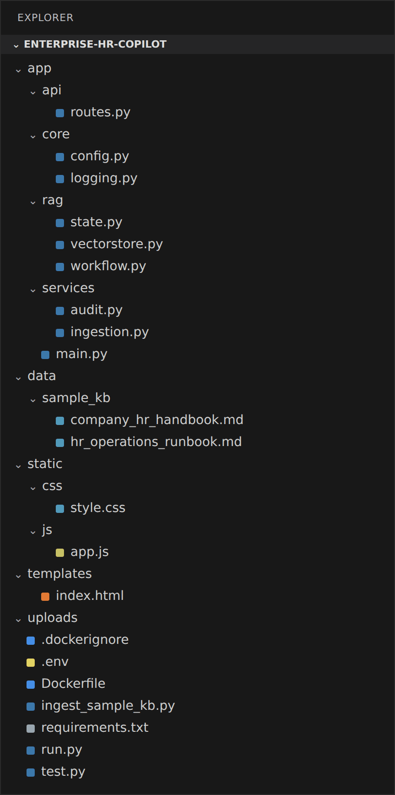
Project structure as shown in the VS Code Explorer

Activity 1.3: Install Project Dependencies
All dependencies are pinned in requirements.txt so that every machine and the Docker image install the same versions. The file groups the web framework (FastAPI, Uvicorn, Jinja2, python-multipart, pydantic-settings), the agent stack (LangGraph, LangChain core and community packages, Gemini, Tavily, Pinecone and HuggingFace integrations), the vector database client, and the document readers (pypdf, python-docx, python-dotenv). The packages are installed with pip install -r requirements.txt.
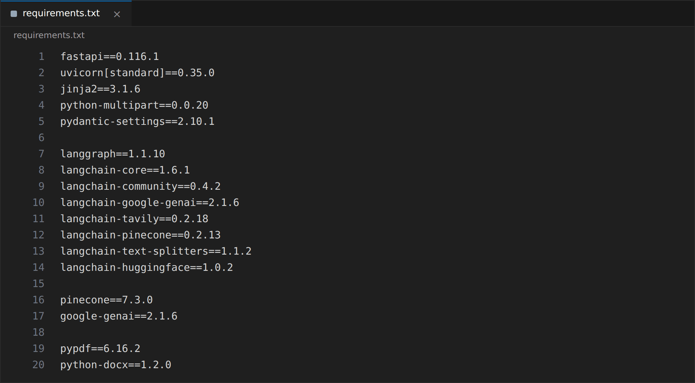

Activity 1.4: Configure API Credentials
Three external services are used: Google Gemini for the language model, Tavily for web search and Pinecone for the vector database. Their keys are stored in a .env file in the project root and are never written into the source code. The file is excluded from version control and from the Docker image, and the key values below are placeholders.
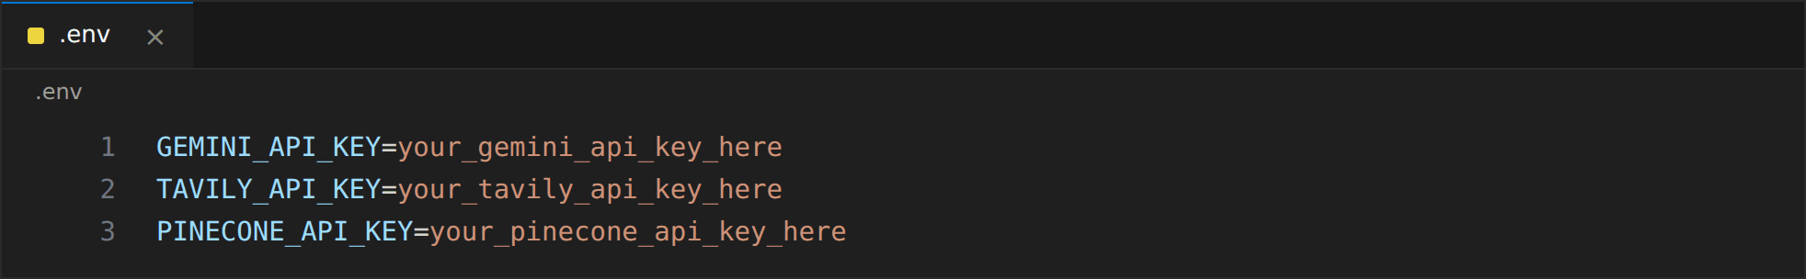
The remaining settings (index name, namespace, embedding model, Gemini model, top-k, retries and admin key) have safe defaults in config.py and can optionally be overridden from the same .env file, for example PINECONE_INDEX_NAME, PINECONE_NAMESPACE, GEMINI_MODEL, EMBEDDING_MODEL and ADMIN_API_KEY.

Activity 1.5: Centralise Application Settings and Logging
app/core/config.py loads every configuration value through a single Settings class built on pydantic-settings. BASE_DIR is resolved from the file location so that paths for the audit database, upload folder and sample knowledge base work from any starting directory, and load_dotenv() reads the .env file at import time. get_settings() is wrapped with lru_cache, so the settings object is created once and shared by the whole application.
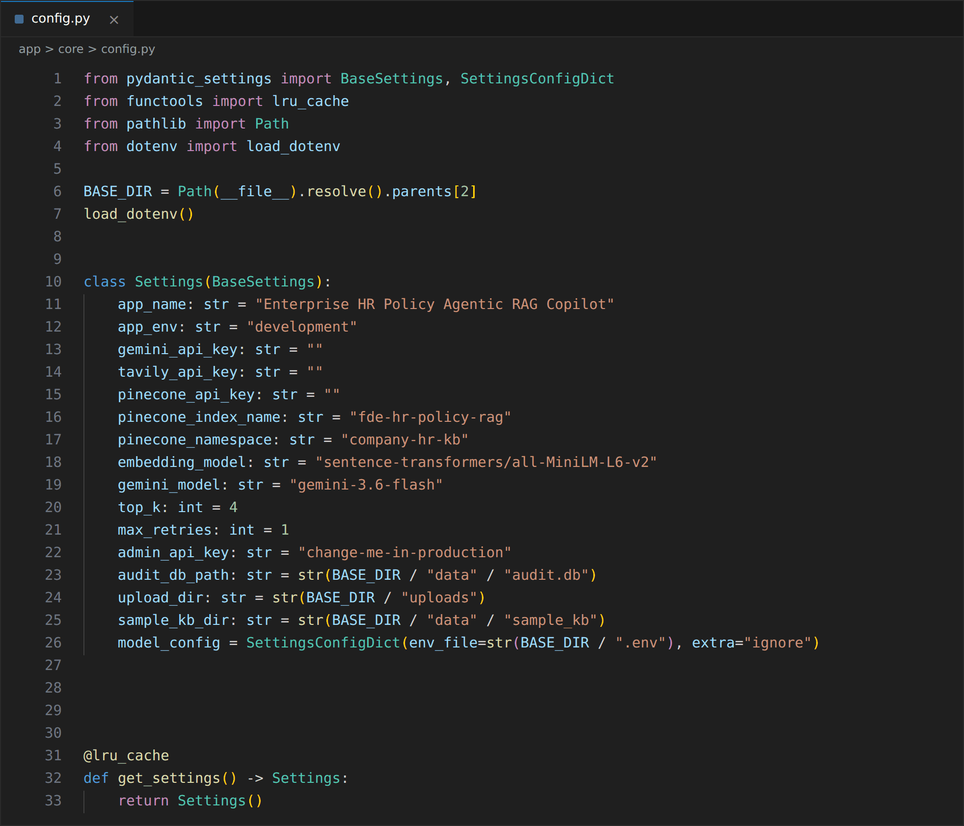
Logging is configured once at startup in app/core/logging.py with a consistent format that includes the timestamp, level, logger name and message.
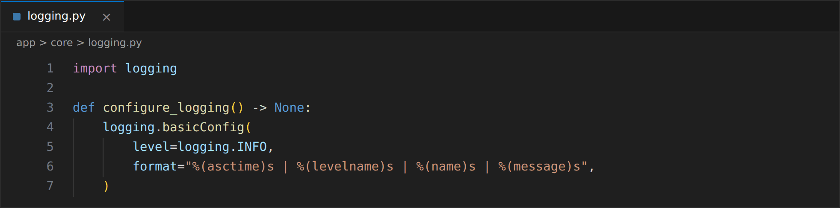

Milestone 2 — Knowledge Base and Document Ingestion
Prepared the private HR knowledge base, built the pipeline that loads and chunks PDF, TXT, Markdown and DOCX files, configured HuggingFace embeddings with a Pinecone serverless index, and created the script that indexes the sample documents.

Activity 2.1: Prepare the Sample HR Knowledge Base
Two sample company documents were placed in data/sample_kb/. The HR handbook covers annual leave, sick leave, remote work, working hours, payroll, benefits and the code of conduct, and the HR operations runbook covers onboarding, leave request support, payroll issue priority and employee record changes. These documents form the private knowledge that the agent searches first.
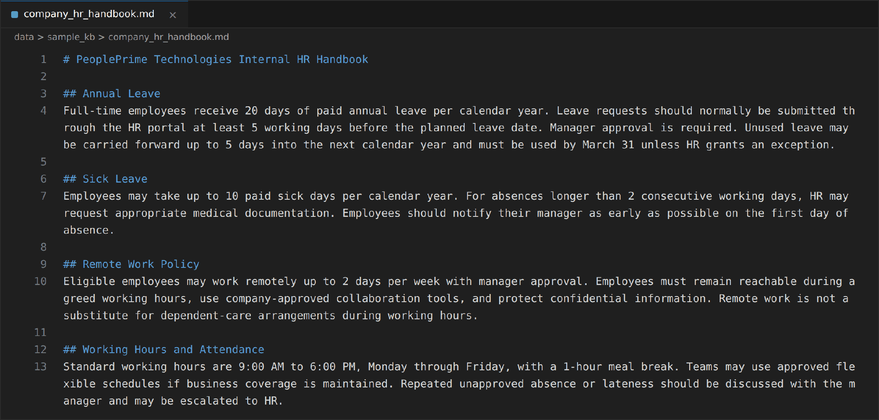
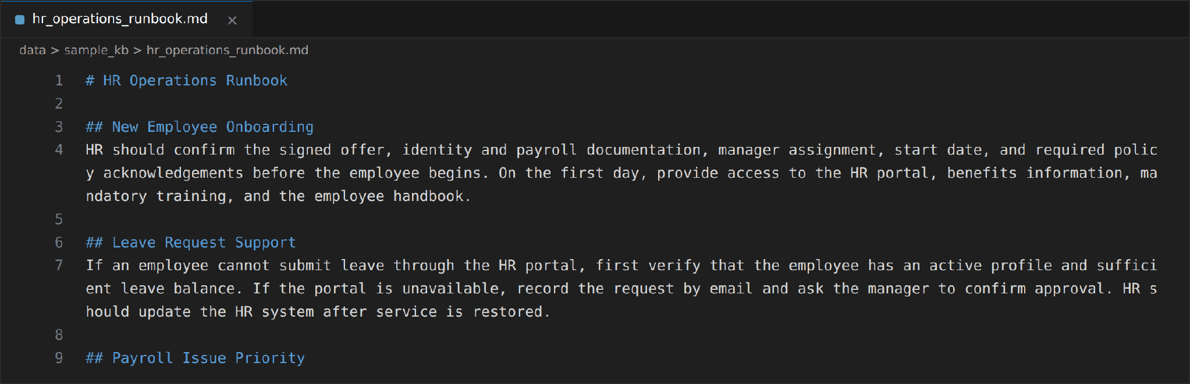

Activity 2.2: Load PDF, TXT, Markdown and DOCX Documents
load_file() in app/services/ingestion.py selects a loader based on the file extension. PDFs are read page by page with PyPDFLoader, TXT and Markdown files with TextLoader using UTF-8, and DOCX files with python-docx by joining the non-empty paragraphs into one document that keeps the file path as its source metadata. Any other extension raises a clear ValueError, and the SUPPORTED set is reused later by the upload endpoint for validation.
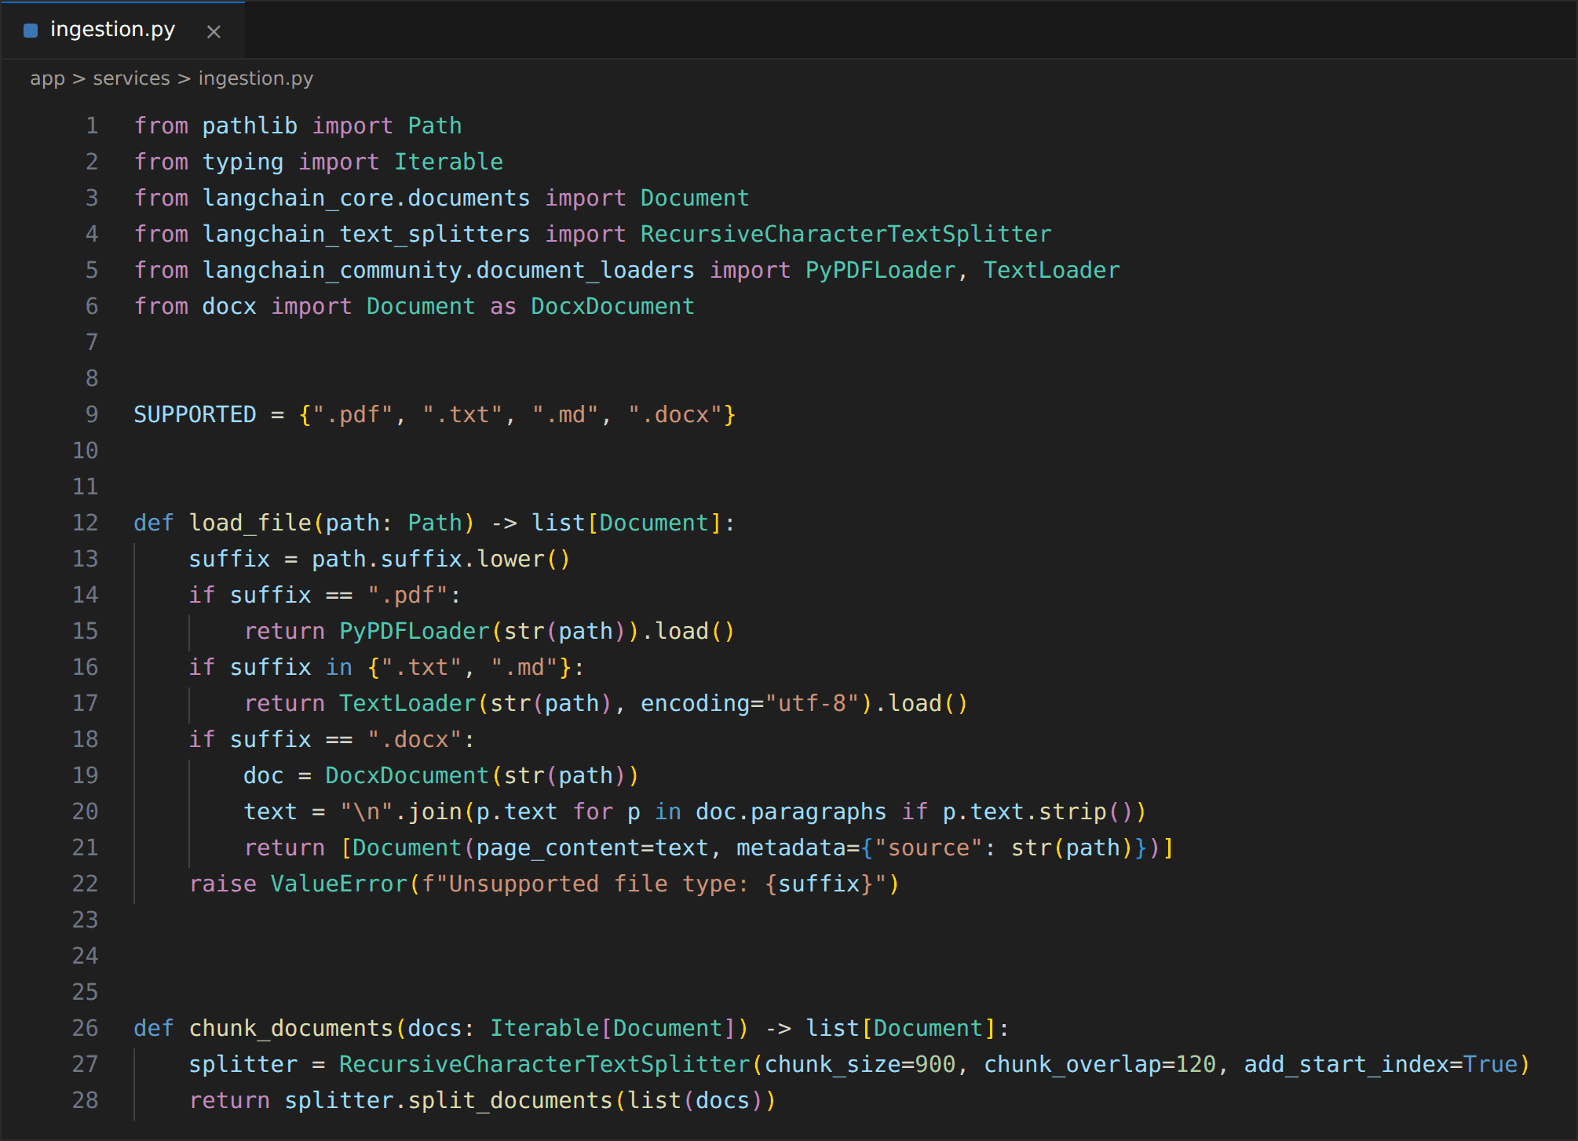

Activity 2.3: Split Documents into Chunks
chunk_documents() uses LangChain's RecursiveCharacterTextSplitter with a chunk size of 900 characters and an overlap of 120 characters, and add_start_index=True stores the starting position of each chunk. The overlap keeps sentences that fall on a chunk boundary available to both neighbouring chunks, which improves retrieval quality. A small test script confirms the behaviour by loading the handbook and printing the number of chunks.
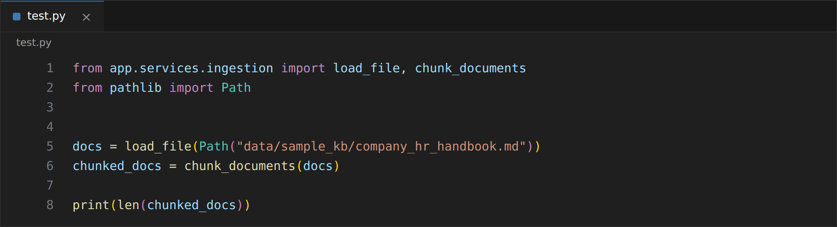
The handbook produces 3 chunks, and the runbook produces 2 chunks, so the complete sample knowledge base contains 5 chunks.

Activity 2.4: Configure Embeddings and the Pinecone Index
app/rag/vectorstore.py maps supported embedding models to their vector dimensions (384 for all-MiniLM-L6-v2) so that the Pinecone index is always created with a matching size. The HuggingFace embedding model is created lazily on first use and reused afterwards.
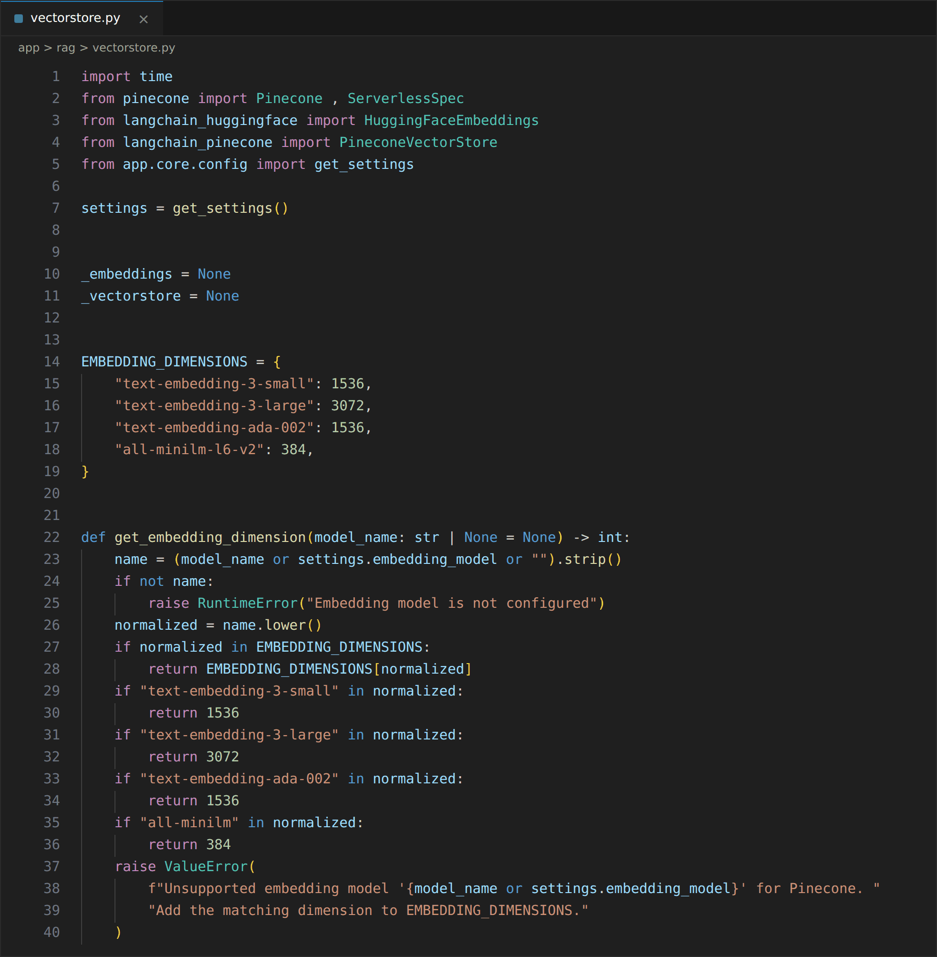
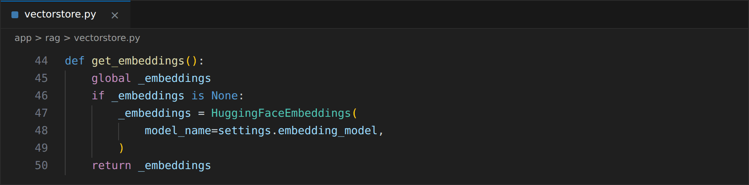
ensure_index() checks that the Pinecone key exists, connects to Pinecone and creates the index if it is missing, using cosine similarity on an AWS us-east-1 serverless specification, and then waits until the index reports ready. If an index with the same name already exists with a different dimension, it is deleted and recreated, so a different index name should be used when another index must be preserved.
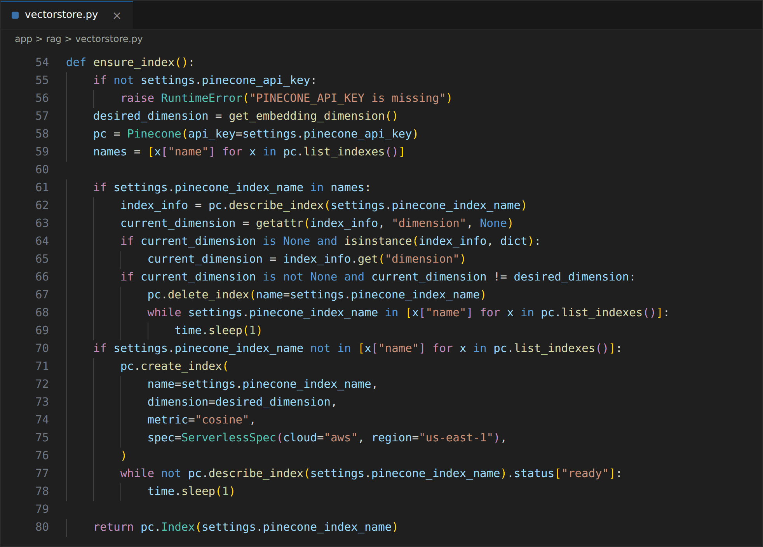

Activity 2.5: Index the Knowledge Base and Verify
get_vectorstore() creates a single PineconeVectorStore bound to the configured namespace, get_retriever() returns a retriever that fetches the top-k chunks (4 by default), and add_documents() embeds and uploads new chunks. The same functions are used by both the ingestion script and the upload API.
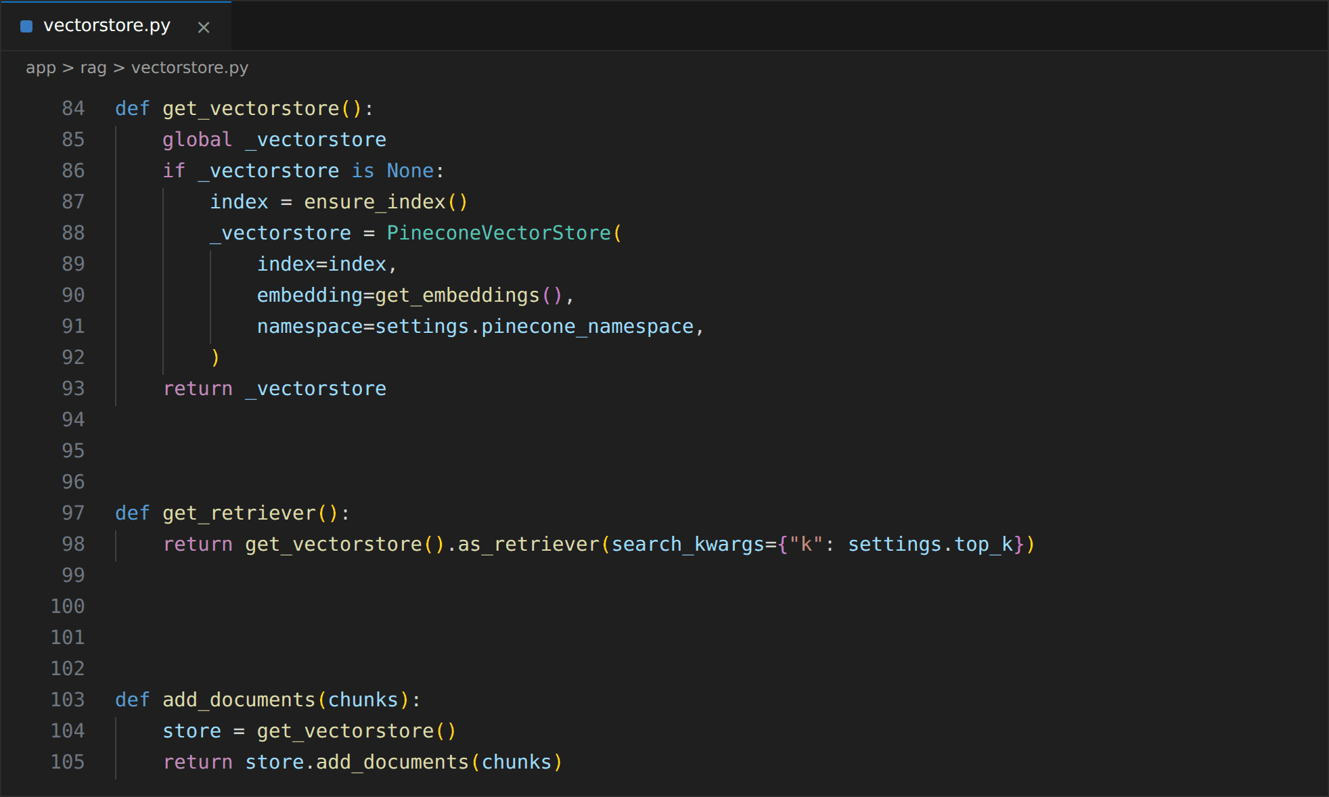
ingest_sample_kb.py reads every file in the sample knowledge base folder, loads and chunks them, uploads them to Pinecone, and prints a summary. For the two sample documents the expected summary is 2 files, 5 chunks and 5 Pinecone vectors. The script is run with python ingest_sample_kb.py.
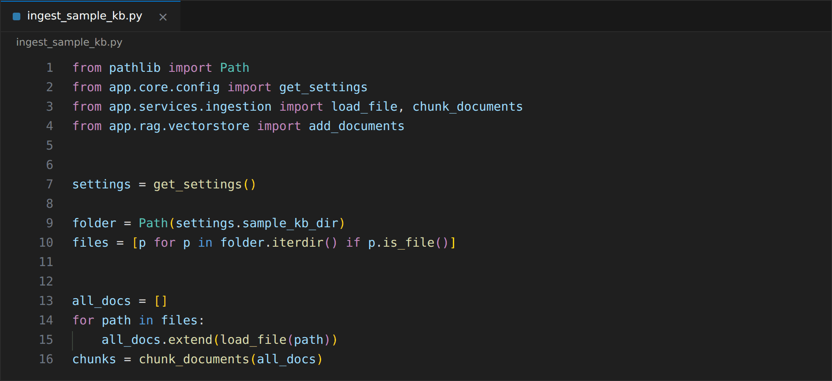

Milestone 3 — AI and LLM Integration
Defined the structured decision schemas and shared state, configured the Gemini language model and the Tavily search tool, and wrote the prompts used for routing, evidence grading, query rewriting and grounded answer generation.

Activity 3.1: Define the Structured Decision Schemas
Two Pydantic models force the language model to return machine-readable decisions instead of free text. RouteDecision allows only the values kb or direct, and EvidenceGrade allows only good or weak. Because the values are restricted with Literal, the workflow can branch safely on them.
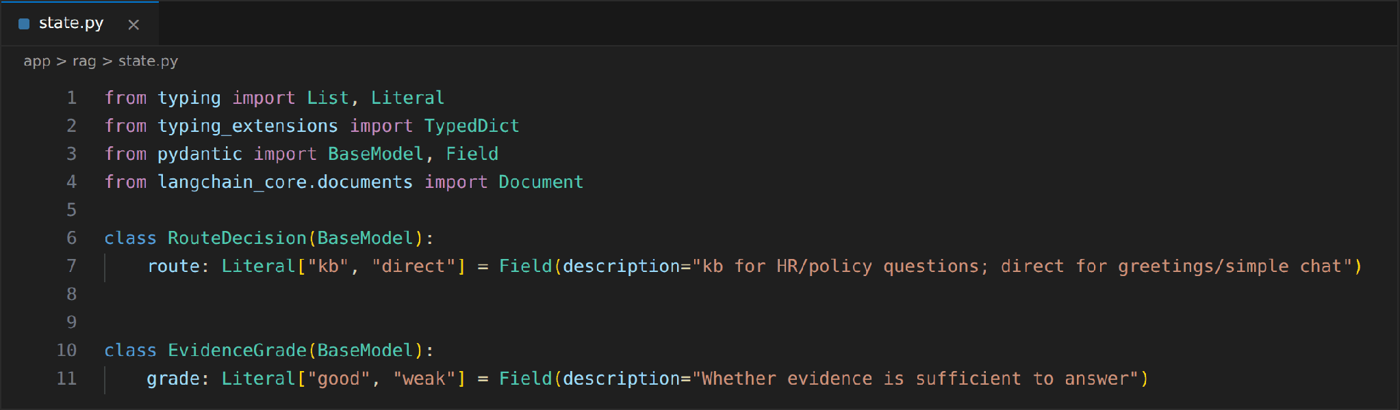

Activity 3.2: Define the Shared Agent State
AgentState is the contract between all nodes. It carries the original question, the current (possibly rewritten) query, the retrieved KB documents, web results, both grades, the final answer, the source used, the retry counter, the execution trace and the citations. Each node returns only the fields it changes, and LangGraph merges them into the state.
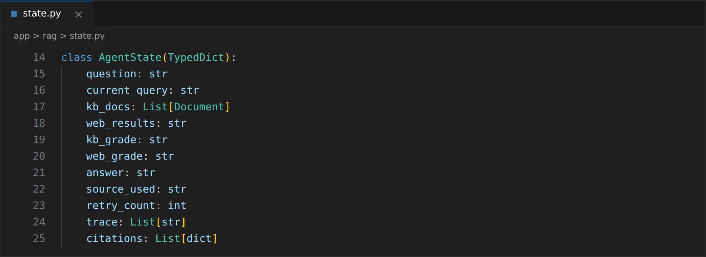

Activity 3.3: Configure the Gemini LLM Client
A single ChatGoogleGenerativeAI client is created lazily and reused by every node. It uses the model from the settings with temperature=0 so that routing and grading are deterministic, and it fails immediately with a clear error if GEMINI_API_KEY is missing. The to_text() helper converts Gemini responses that arrive as a list of content blocks into a plain string before they are sent to the frontend.
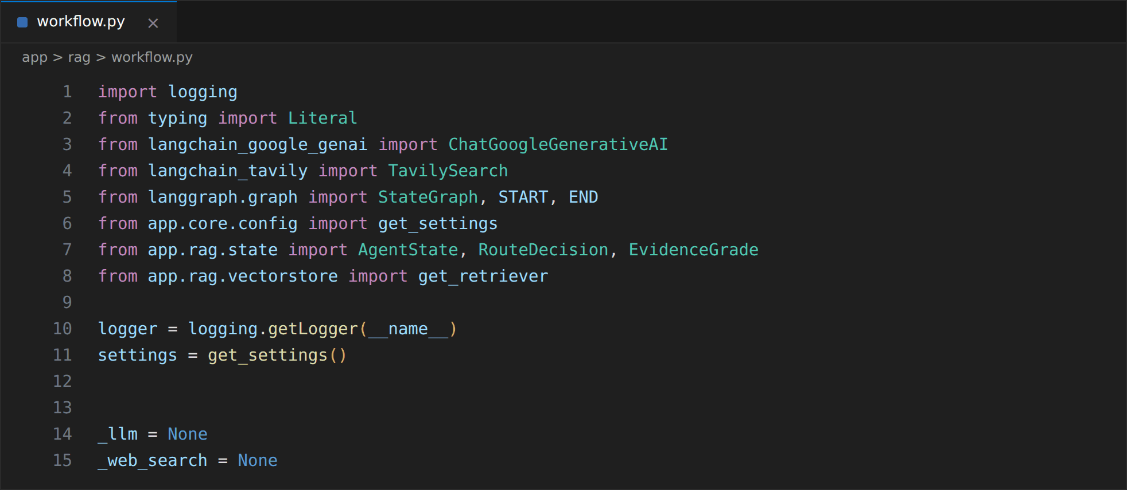
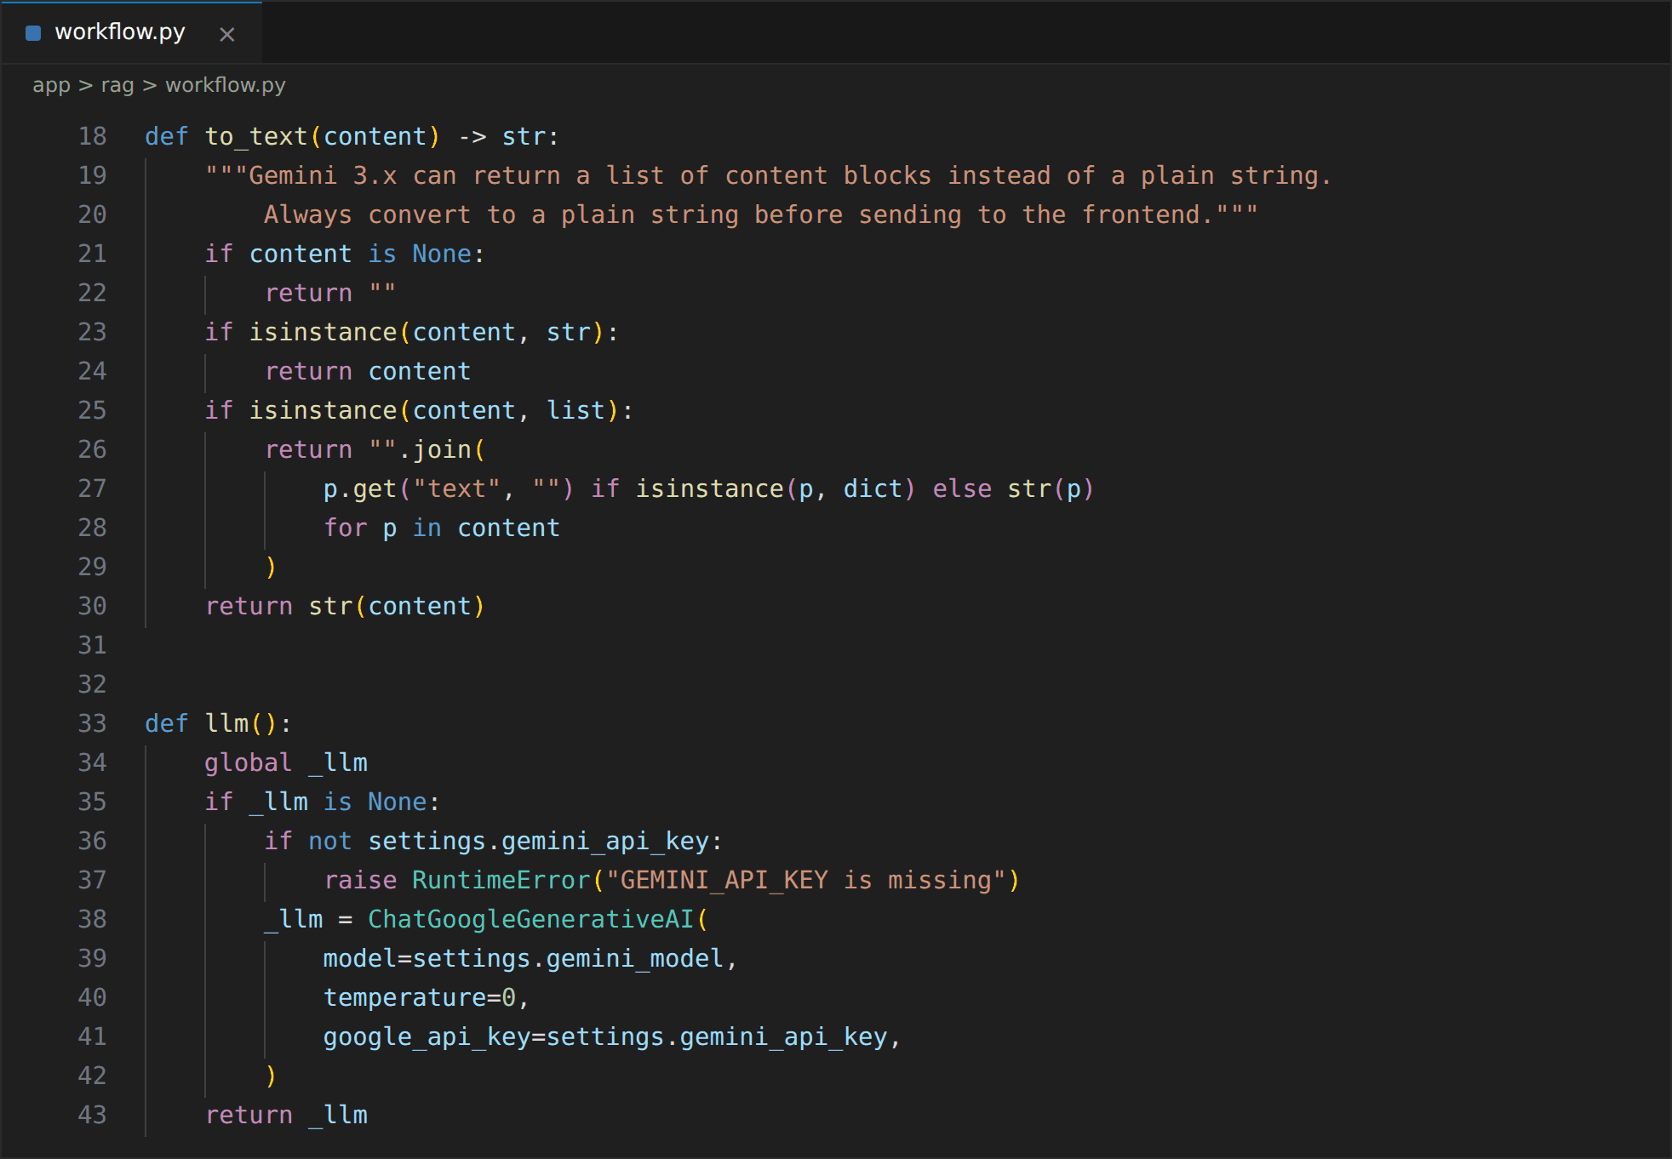

Activity 3.4: Configure the Tavily Web Search Tool
The Tavily client is also created once on first use. It returns up to 5 results for the general topic, includes Tavily's short generated answer, and excludes raw page content to keep the evidence compact. The helper add_trace() below is used by every node to append a readable step to the execution trace.
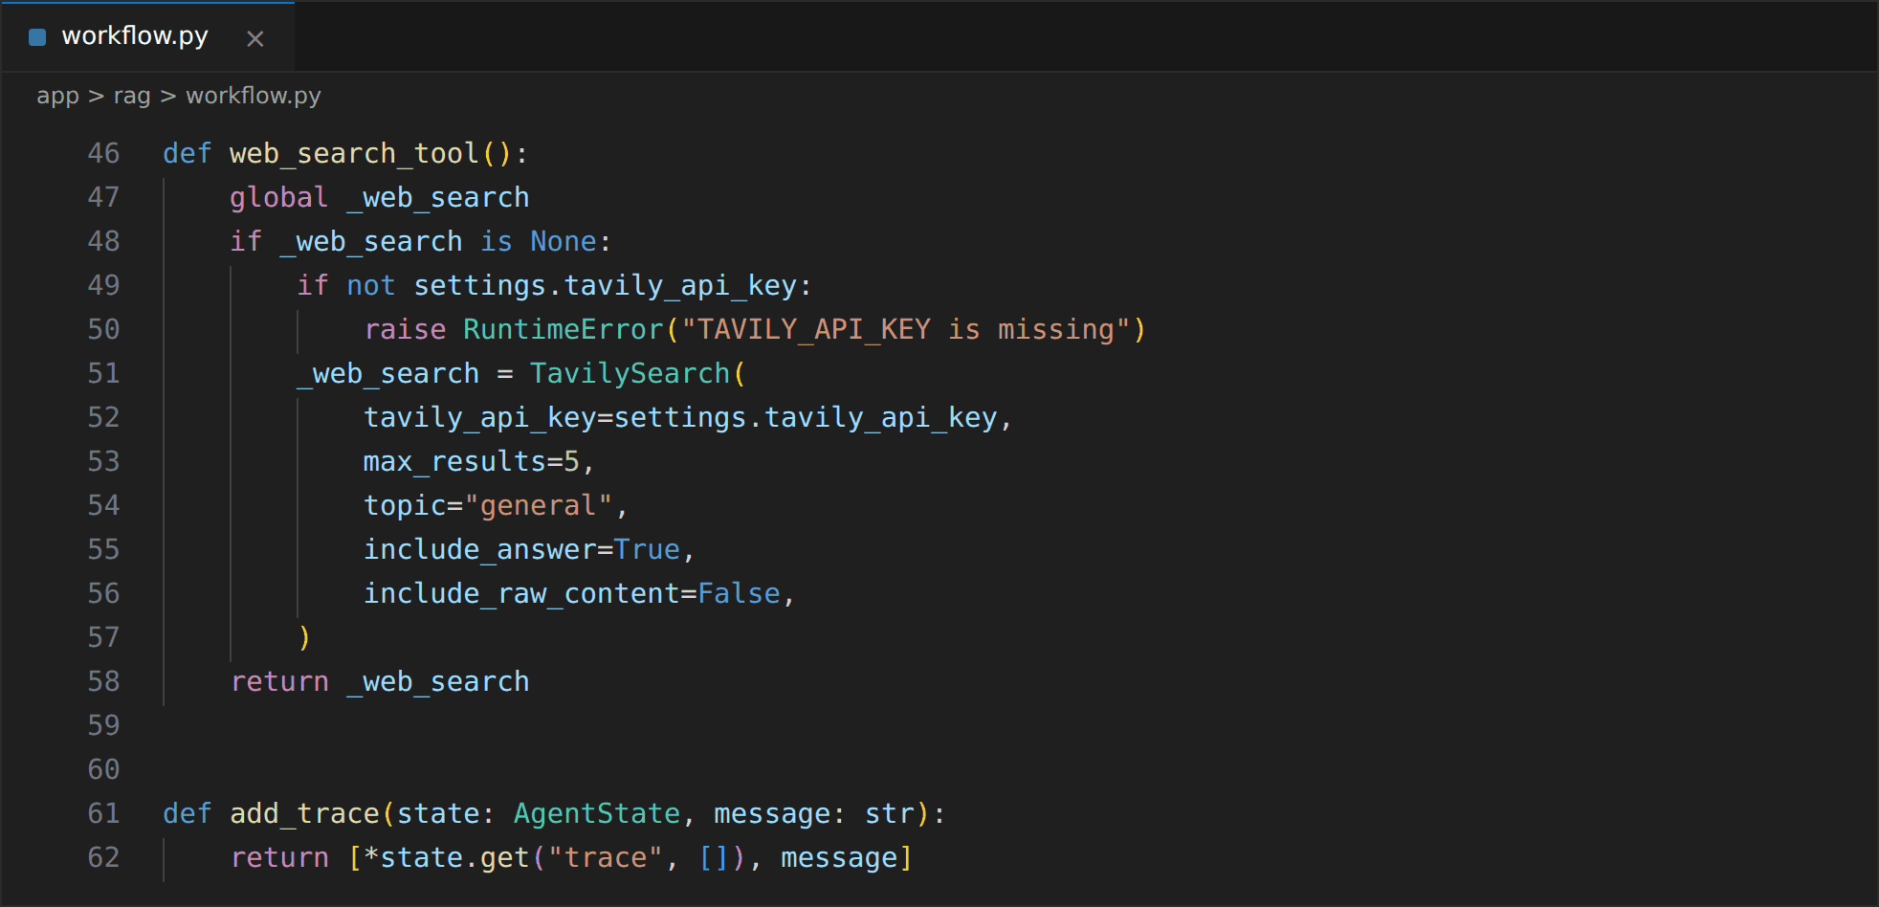

Activity 3.5: Construct the Router, Grader and Rewrite Prompts
The router prompt tells Gemini to choose kb for HR topics such as leave, payroll, remote work, benefits and conduct, and direct only for greetings and casual chat. The model is bound to the RouteDecision schema with JSON mode.
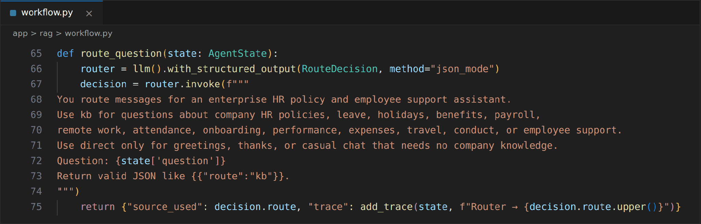
The KB grader receives the question and the retrieved chunks with their sources, and answers good only if the evidence is sufficient to answer confidently and specifically. The web grader works the same way on the Tavily results.
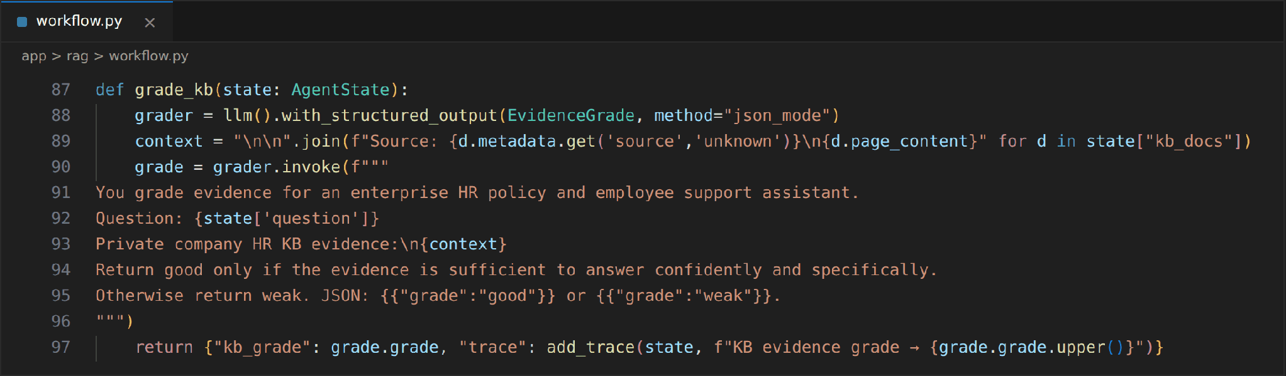
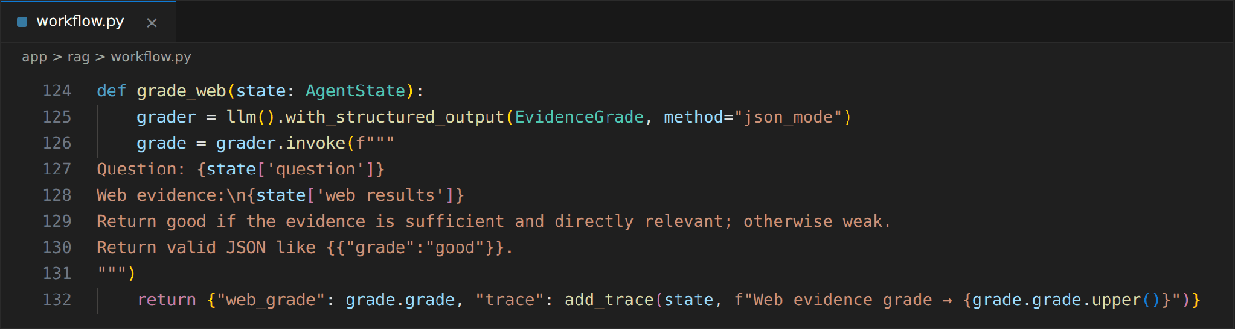
When both sources are weak, the rewrite prompt turns the question into a better search query by adding HR and policy keywords while preserving the intent, and increments the retry counter.
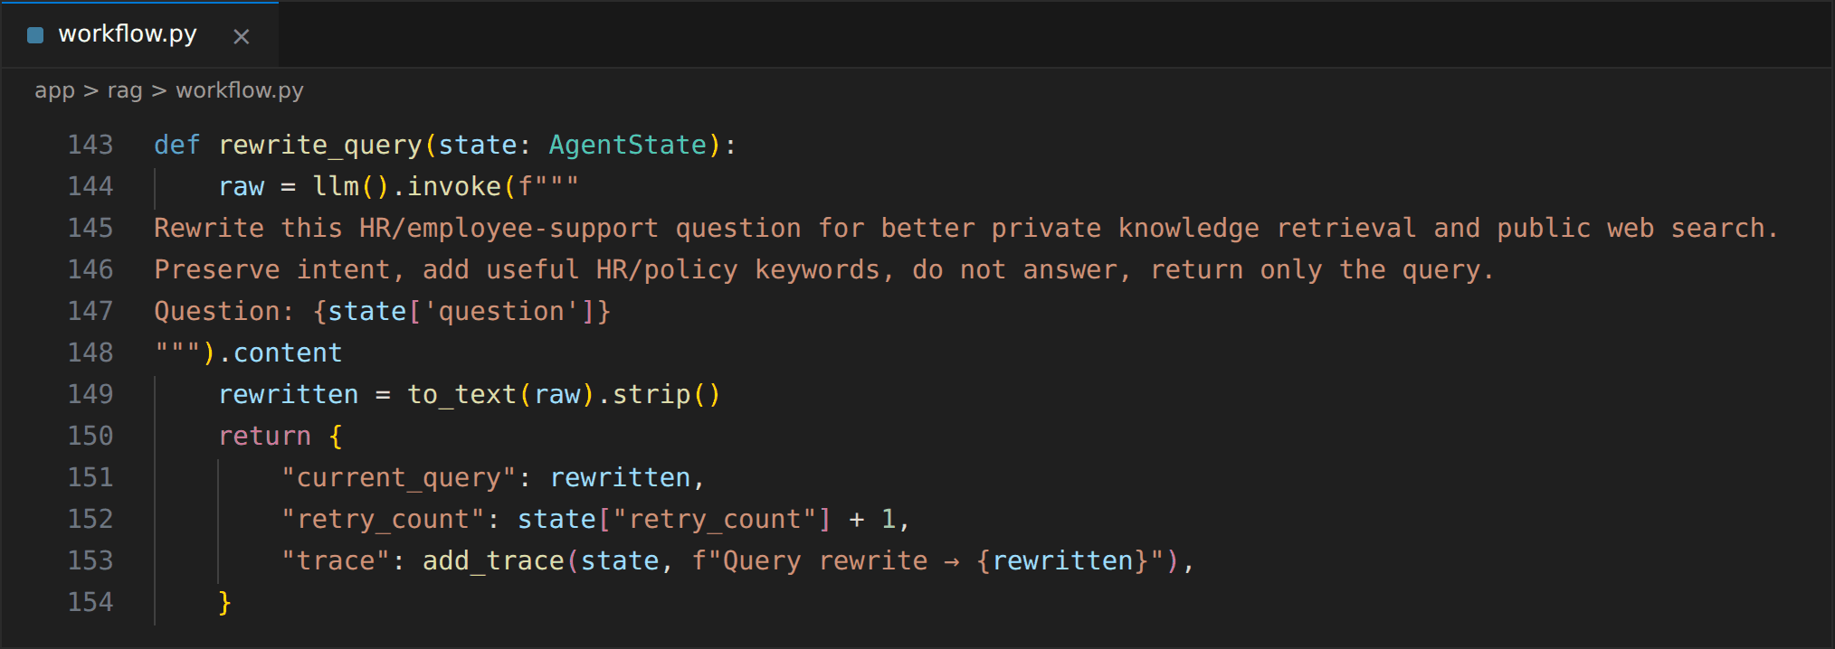

Activity 3.6: Construct the Answer Generation Prompts
The private KB answer prompt restricts Gemini to the retrieved company documents, forbids inventing policy details, and asks it to mention that the answer comes from the private knowledge base. The unique source files are returned as citations.
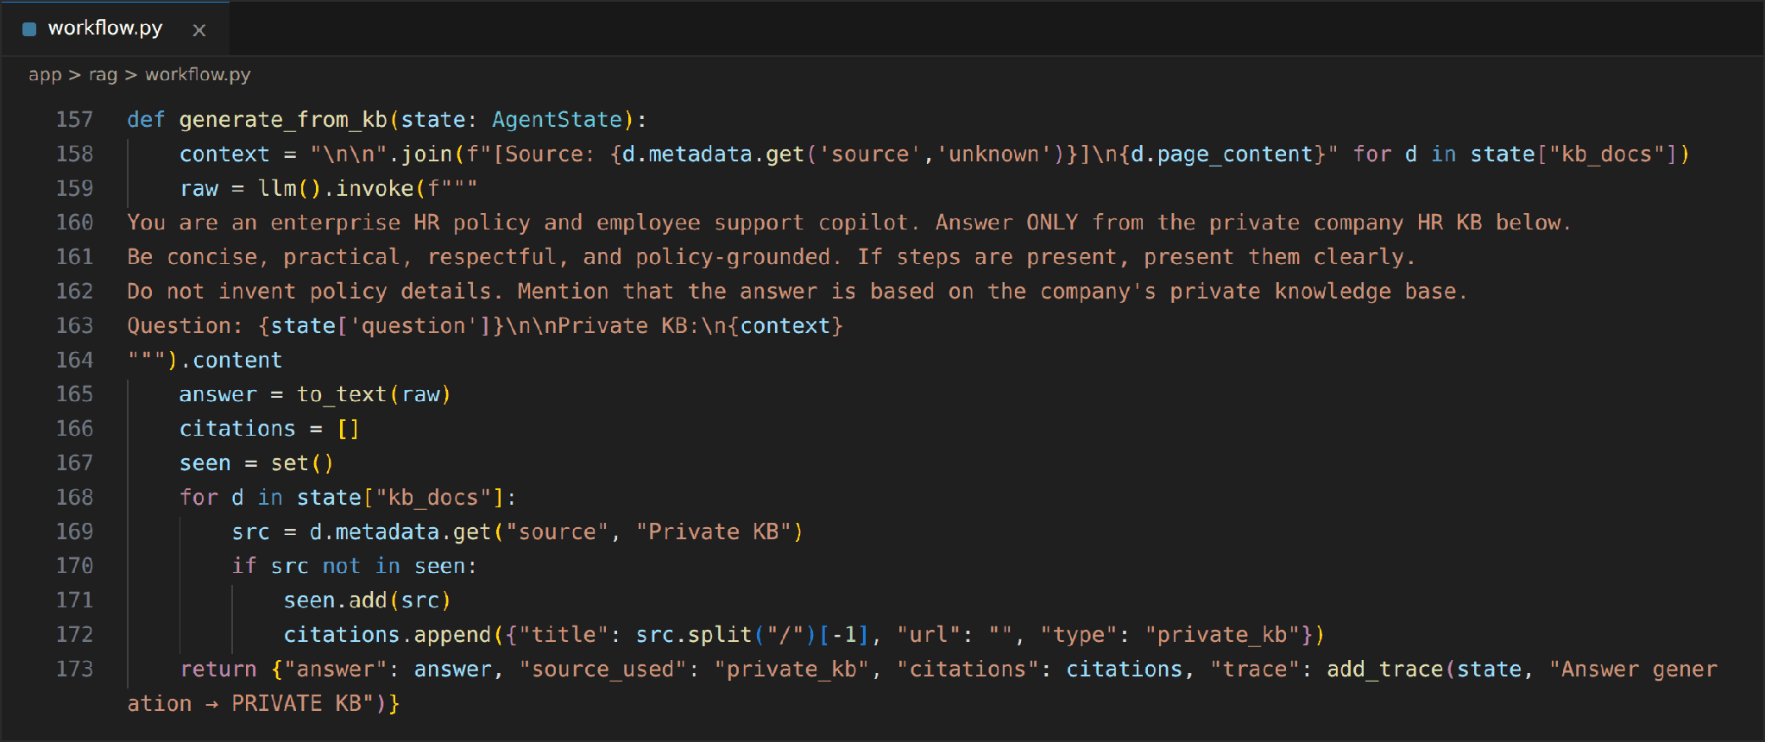
The web answer prompt works only from the Tavily evidence and must state that the information is external and may require HR validation. A separate short prompt handles greetings directly without retrieval.
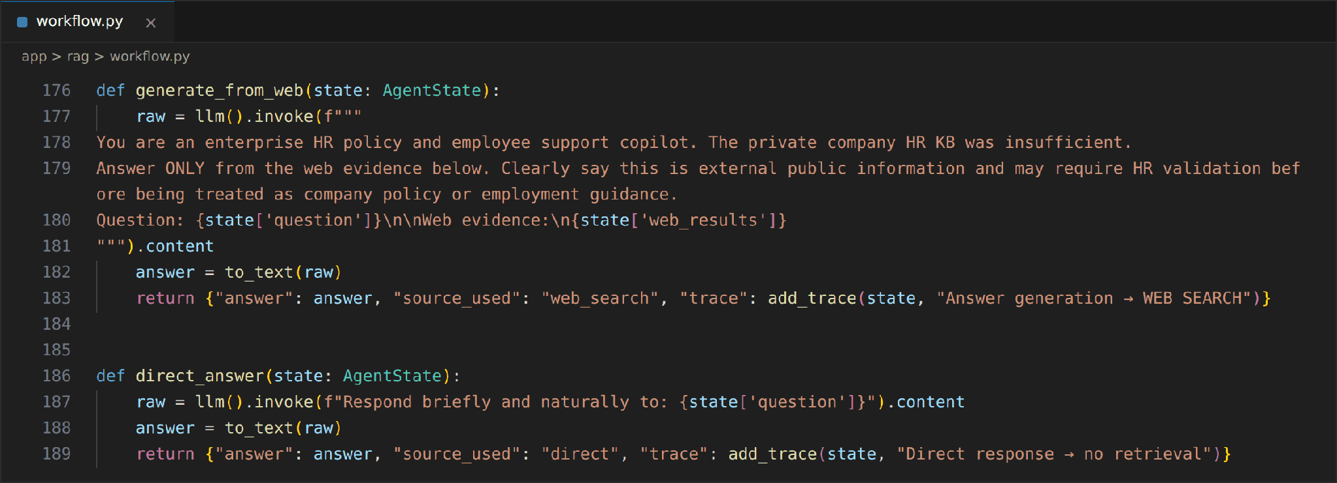

Milestone 4 — Agentic RAG Workflow with LangGraph
Implemented the retrieval and web search nodes, the conditional routing logic and the safe fallback, and connected all ten nodes into a LangGraph state machine that is exposed through a single ask() function.

Activity 4.1: Implement the Trace Helper and KB Retrieval Node
route_after_router() sends kb questions to retrieve_kb and everything else to direct_answer. retrieve_kb queries Pinecone with the current query, which may already be a rewritten one, stores the chunks in kb_docs, and records how many chunks were found.
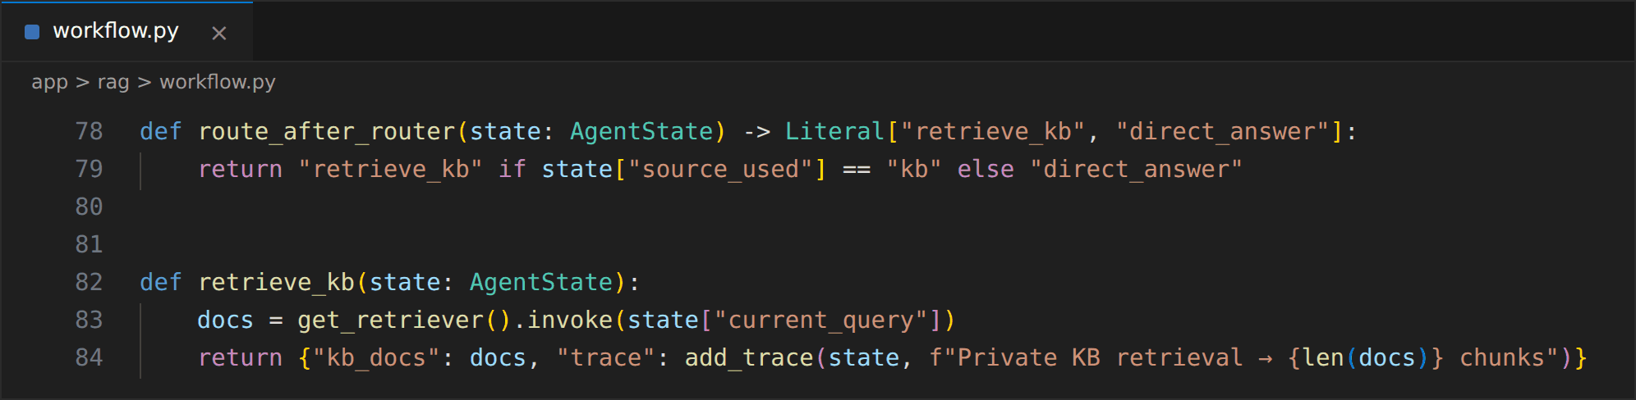

Activity 4.2: Implement the Web Search Node
search_web calls Tavily with the current query and converts the response into a text block containing the search answer, titles, URLs and content. It also creates a citation for each result with the type web, so the interface can display clickable sources.
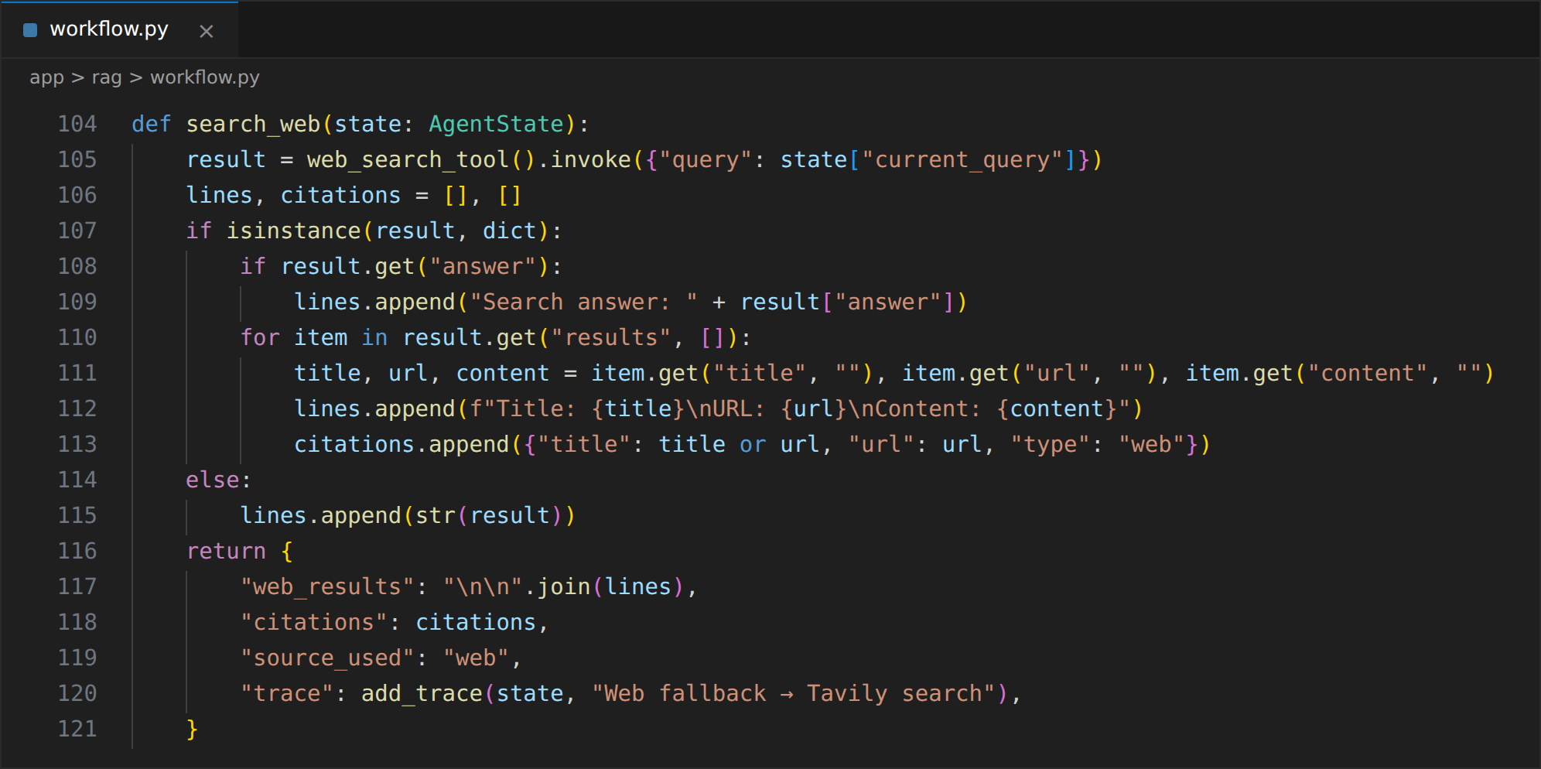

Activity 4.3: Implement the Conditional Routing Functions
Two decision functions control the agent. After grading the KB evidence, a good grade goes to generate_from_kb and a weak grade goes to search_web. After grading the web evidence, a good grade goes to generate_from_web; otherwise the agent rewrites the query while retry_count is below max_retries, and stops with insufficient when the retry budget is used up.
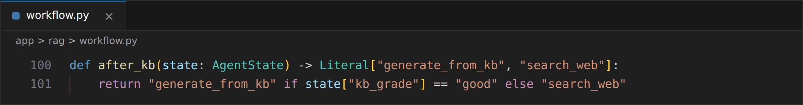
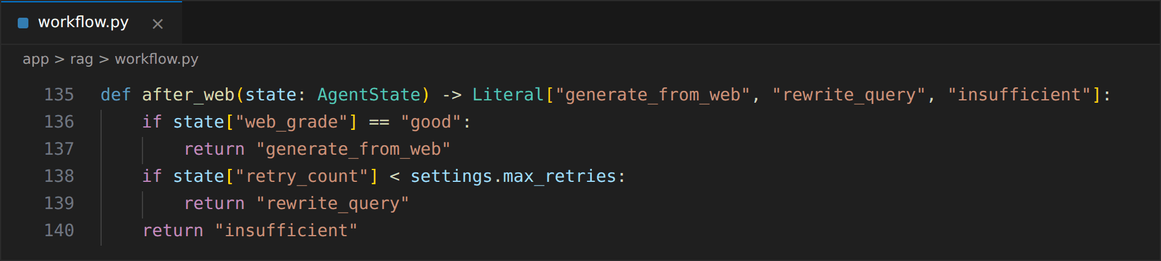

Activity 4.4: Implement the Insufficient-Evidence Node
The insufficient node is the safety net of the workflow. Instead of producing an unsupported answer, it returns a fixed message asking the employee to contact HR or add more detail, and records the stop in the trace.
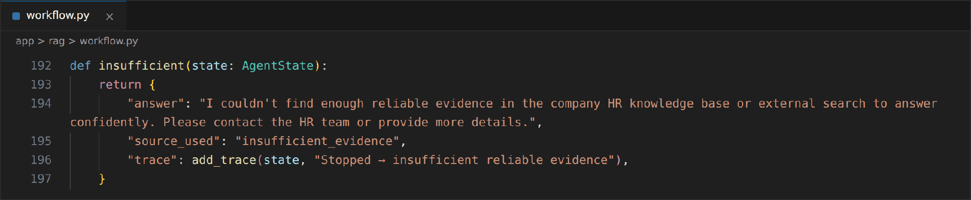

Activity 4.5: Build and Compile the LangGraph Graph
build_graph() registers the ten nodes, sets route_question as the entry point, adds the three conditional edges and the fixed edges, and compiles the graph. The edge from rewrite_query back to retrieve_kb creates the retry loop, and every terminal node connects to END.
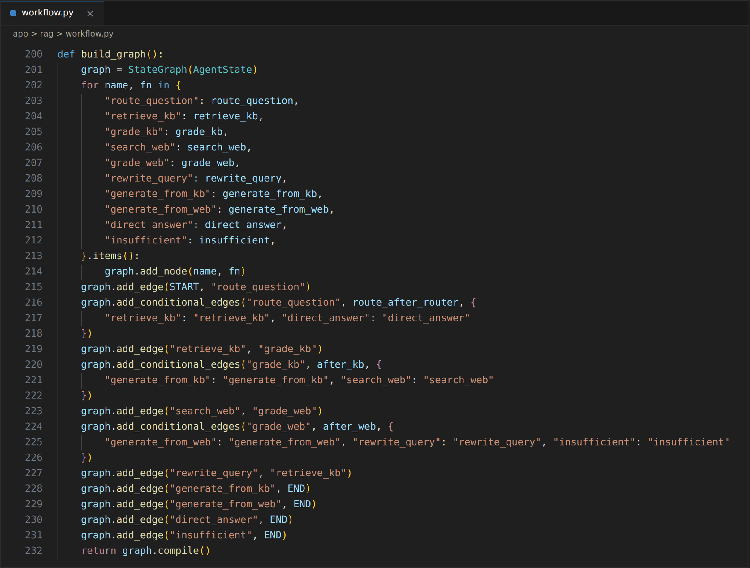
The diagram below visualises the same graph, including the routing labels and the retry loop.
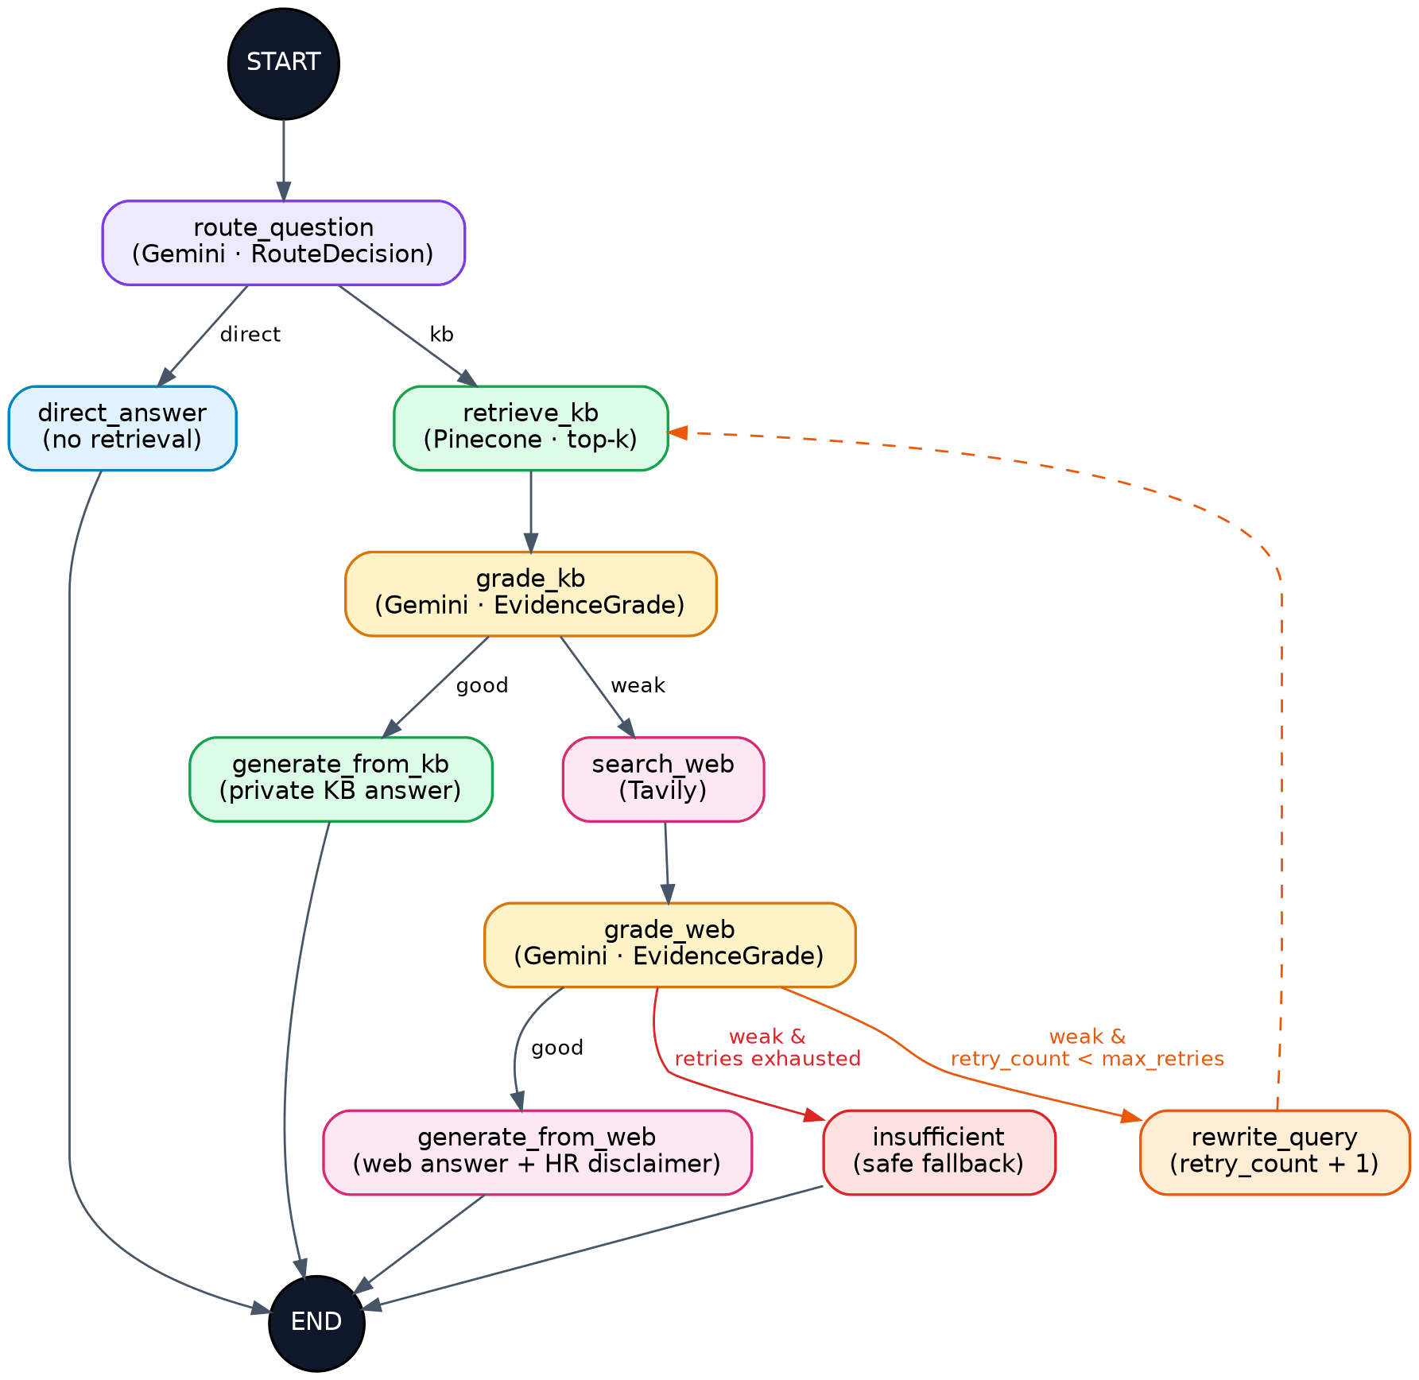
LangGraph workflow generated from build_graph()

Activity 4.6: Expose the Workflow Through ask()
ask() is the single entry point used by the API. It seeds every state field with a safe initial value, so each request starts clean, and invokes the compiled graph. The returned dictionary contains the answer, source, trace, citations and current query. Because the web layer imports only this function, the workflow can be changed without touching the API.
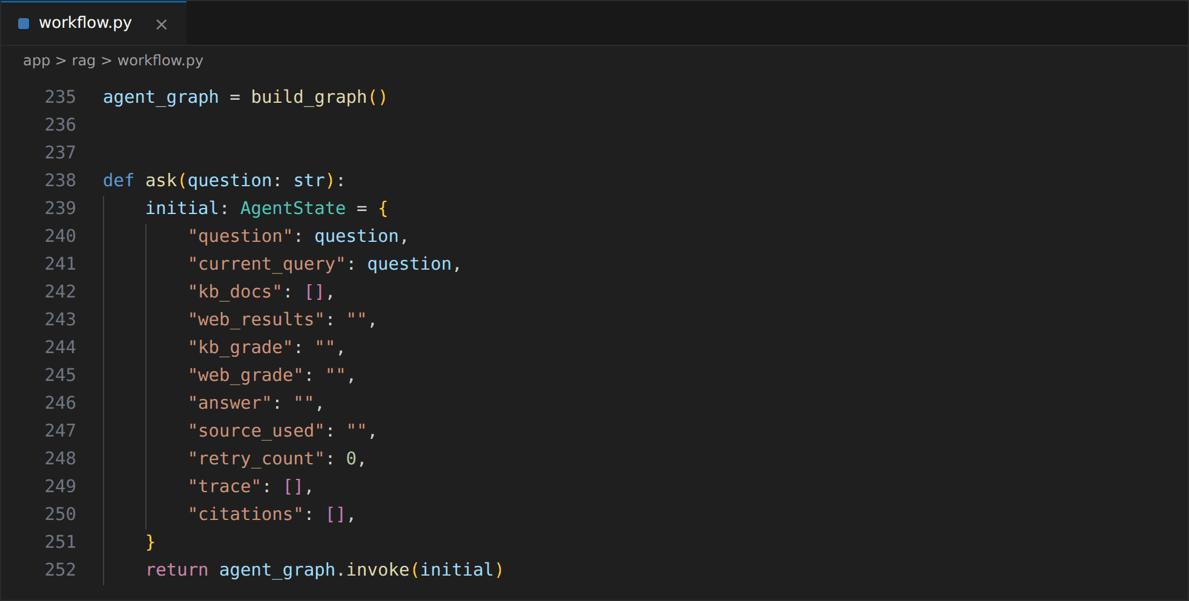

Milestone 5 — FastAPI Backend and Audit Logging
Developed the FastAPI application that receives questions, validates the input, returns structured responses, supports protected document ingestion, records every request in an SQLite audit database, and can be started locally with run.py.

Activity 5.1: Initialise the FastAPI Application
app/main.py configures logging, loads the settings and initialises the audit database before creating the FastAPI application. It then includes the API router, mounts the /static folder, sets up the Jinja2 templates using the absolute BASE_DIR, and serves the home page at /.
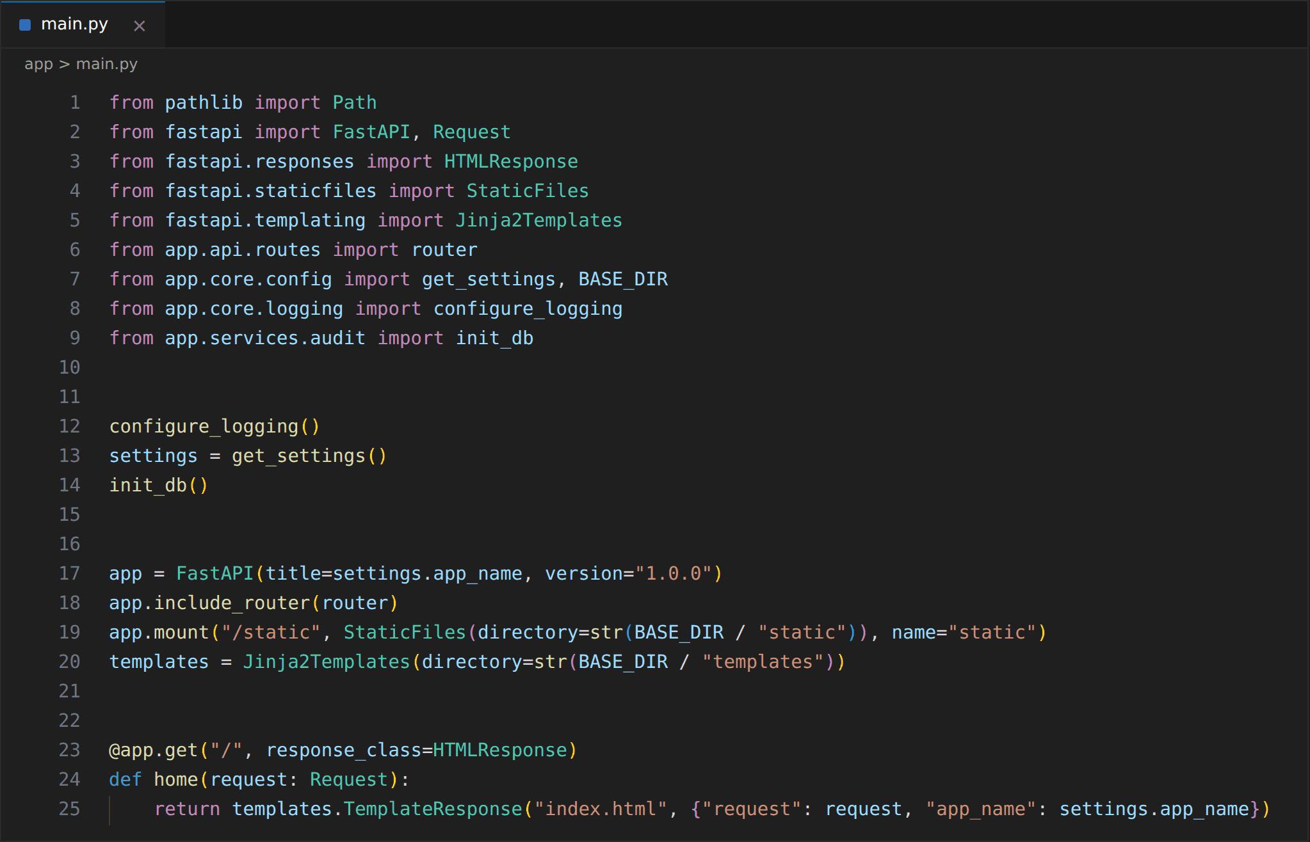

Activity 5.2: Define the Request Schema and Validation
The chat request is validated by a Pydantic model. The question field is required and must contain between 2 and 3000 characters, so empty, missing or oversized input is rejected by FastAPI with an HTTP 422 response before it reaches the language model.
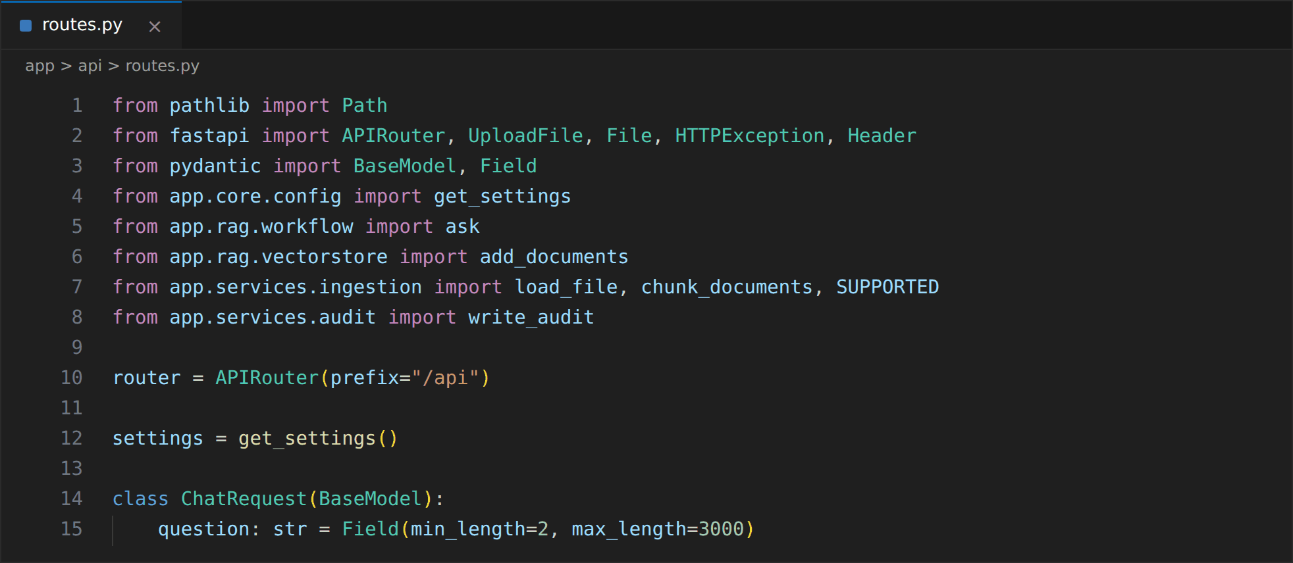

Activity 5.3: Implement the Health and Chat Endpoints
GET /api/health returns the status and service name and can be used by deployment platforms to check that the service is alive. POST /api/chat calls ask(), writes the audit record, and returns the answer, source, trace, citations and the rewritten query. Any failure is converted into an HTTP 500 response that contains the error detail.
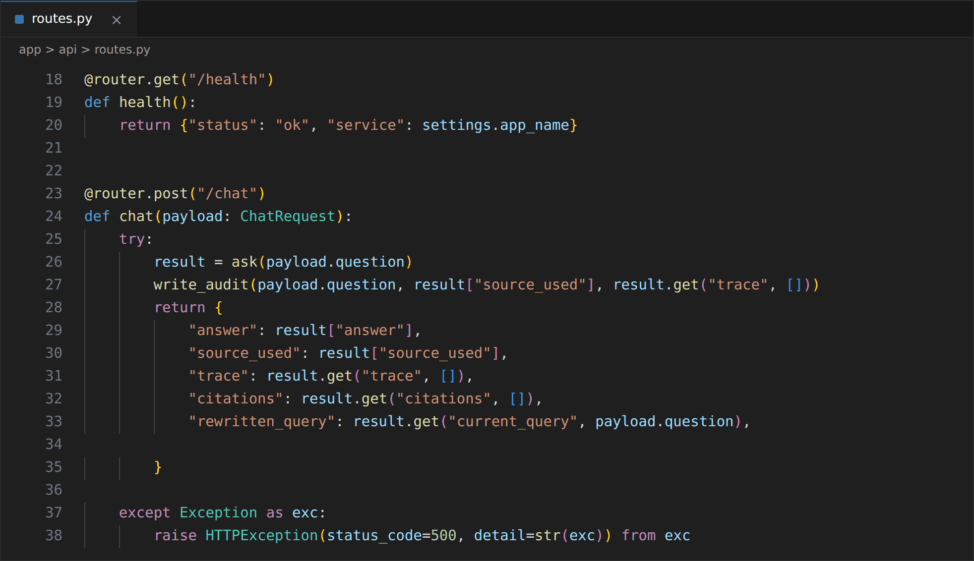
An example of the JSON returned by a successful chat request:
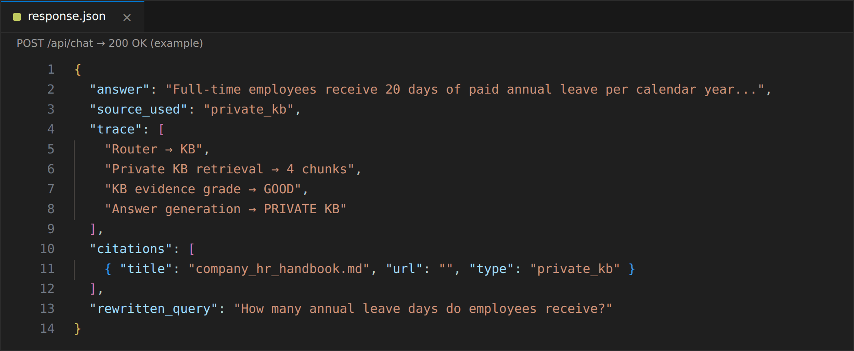

Activity 5.4: Implement the Protected Ingestion Endpoint
POST /api/ingest lets HR administrators add documents. The request must include the X-Admin-Key header matching ADMIN_API_KEY, otherwise a 401 error is returned. The file extension is checked against the supported list (400 on failure), the file is saved to the uploads folder using only its base file name to avoid path tricks, and it is then loaded, chunked and indexed into Pinecone. The response reports the file name, the number of chunks and the number of vectors created.
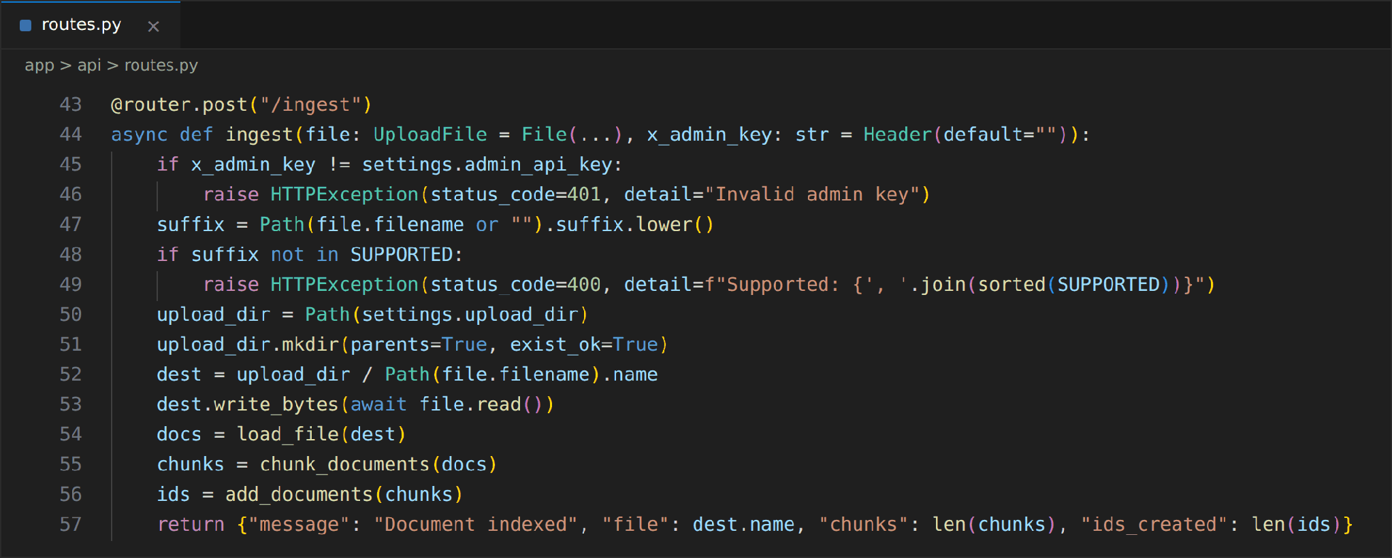

Activity 5.5: Implement SQLite Audit Logging
app/services/audit.py creates a query_audit table with the ID, UTC timestamp, question, final source and the full trace stored as JSON. write_audit() is called after every successful chat request, which gives the HR team a record of what was asked, where the answer came from and which path the agent followed.
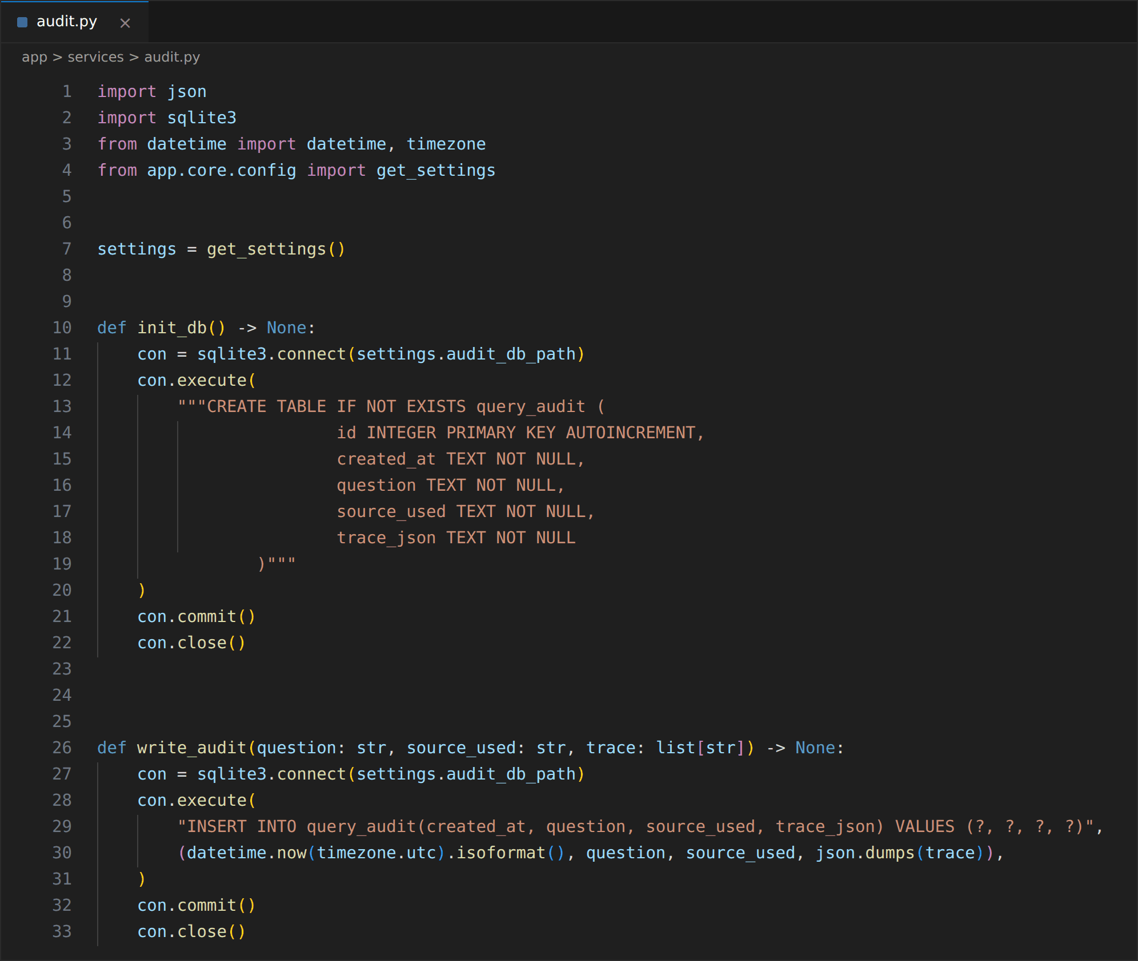

Activity 5.6: Configure Local Execution
run.py starts Uvicorn on 127.0.0.1:8080 with auto-reload enabled, which is suitable for development. The application is started with python run.py, the interface opens at http://127.0.0.1:8080, and the automatically generated API documentation is available at /docs.
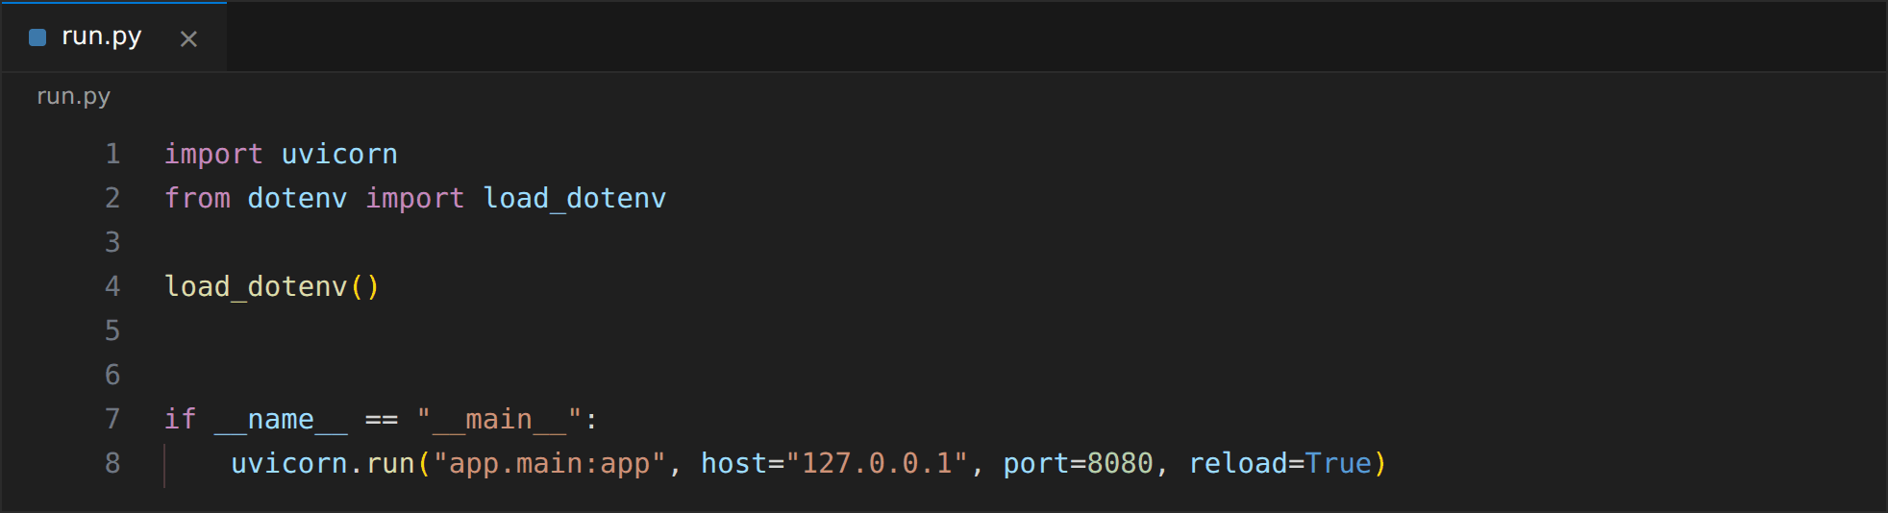

Milestone 6 — User Interface Development and Walkthrough
Built the browser interface with a chat area, workflow panel, live agent trace and a document upload dialog, connected it to the FastAPI endpoints, and walked through the main question scenarios.

Activity 6.1: Build the Page Layout
templates/index.html is rendered by Jinja2 and uses a three-column layout. The left sidebar shows the project badge, a summary of the LangGraph workflow and the "Add HR Document" button. The centre column holds the chat area, example question buttons and the question box. The right column shows the live Agent Trace and the final source.
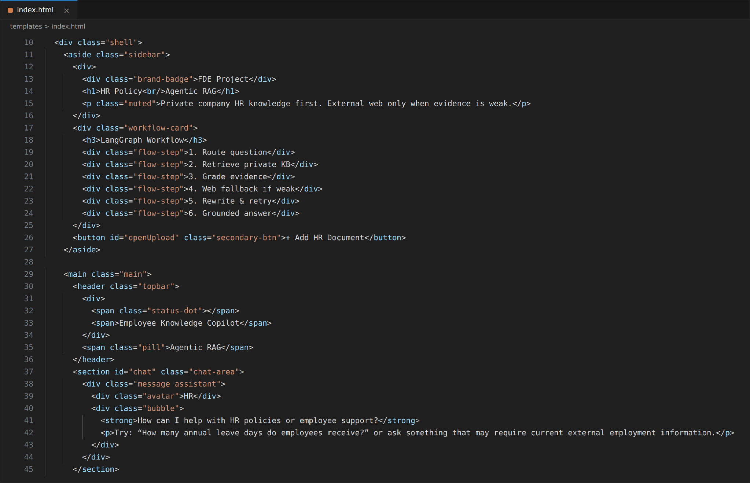
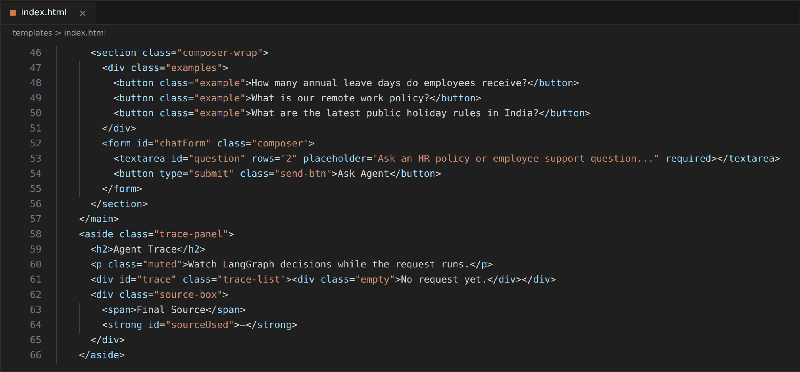
The upload dialog is a modal that accepts an admin key and a PDF, TXT, Markdown or DOCX file.
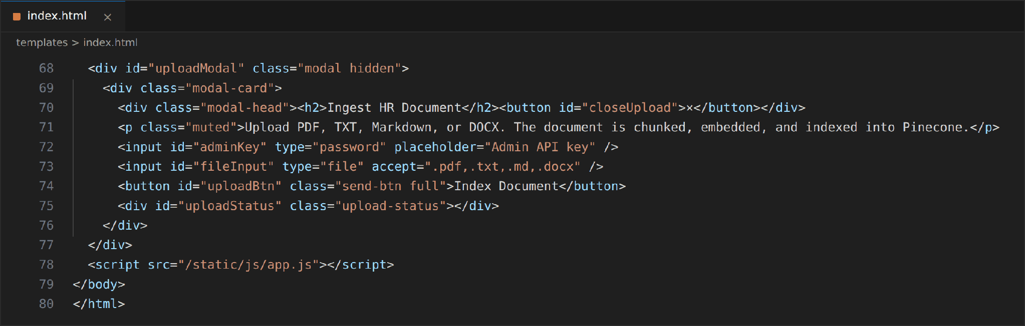

Activity 6.2: Style the Interface
static/css/style.css gives the application a dark, professional enterprise look. A CSS grid with columns of 270px, flexible and 310px creates the three panels, and rounded cards, a green accent colour, a status indicator and clearly separated chat bubbles make the conversation easy to read. The static files are served from the /static mount created in Milestone 5.

Activity 6.3: Connect the Interface to /api/chat
In static/js/app.js, askAgent() adds the user message, shows "Running LangGraph workflow..." in the trace panel, disables the send button and posts the question to /api/chat. When the response arrives, it displays the answer with its source and citations, renders every trace step and updates the final source. User-supplied and model-supplied text is passed through escapeHtml() before it is inserted into the page, and errors are shown as an assistant message.
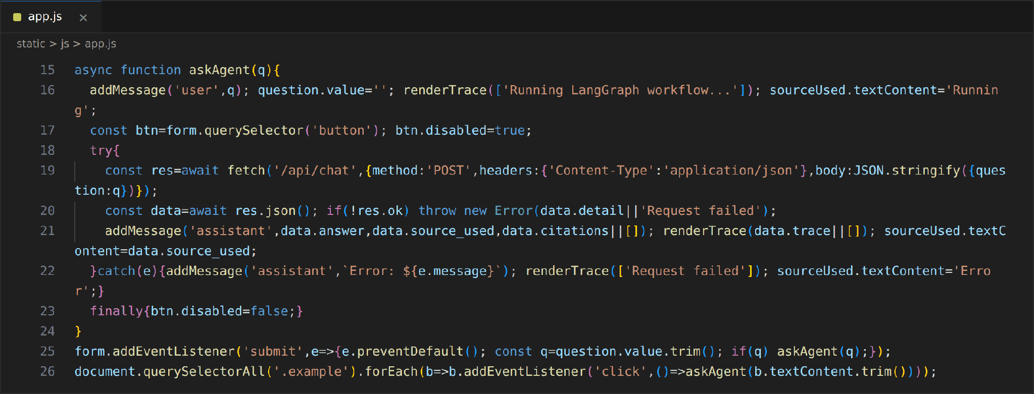

Activity 6.4: Implement the Document Upload Modal
The upload button reads the selected file and the admin key, sends them to /api/ingest as form data with the X-Admin-Key header, and shows either the number of indexed chunks or the error message returned by the server.
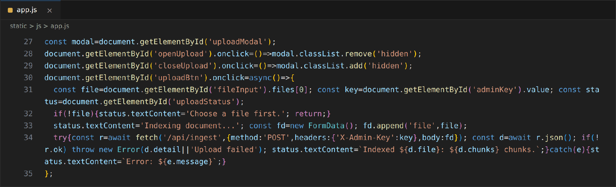

Activity 6.5: Walk Through the User Interface
The complete interface was opened in the browser to review the layout. The page is divided into the workflow sidebar, the chat area and the agent trace panel.
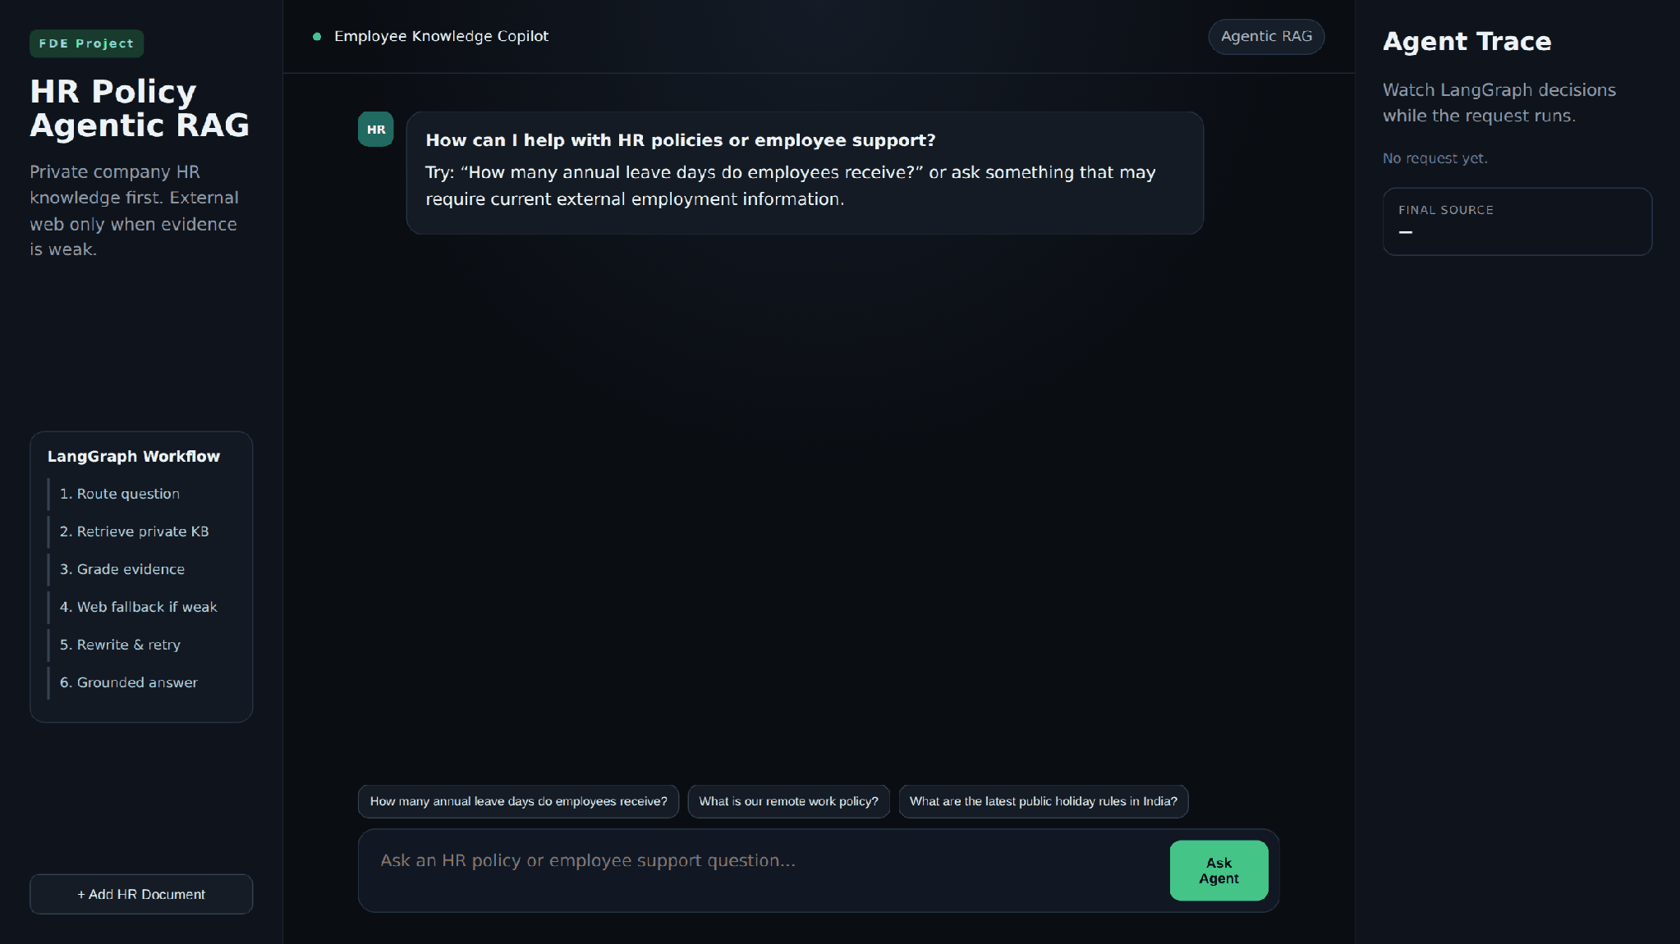
Enterprise HR Copilot — landing page
The individual parts of the interface are shown below.
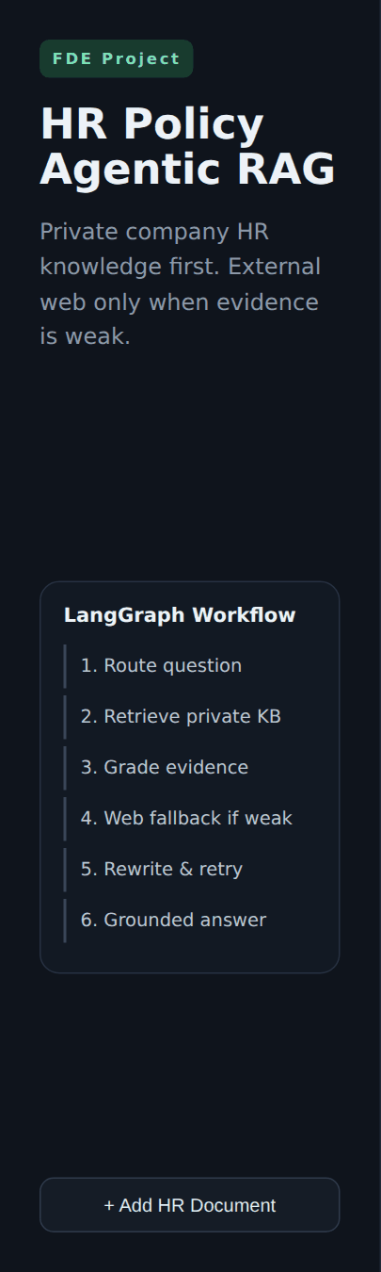  Sidebar: workflow summary and upload | 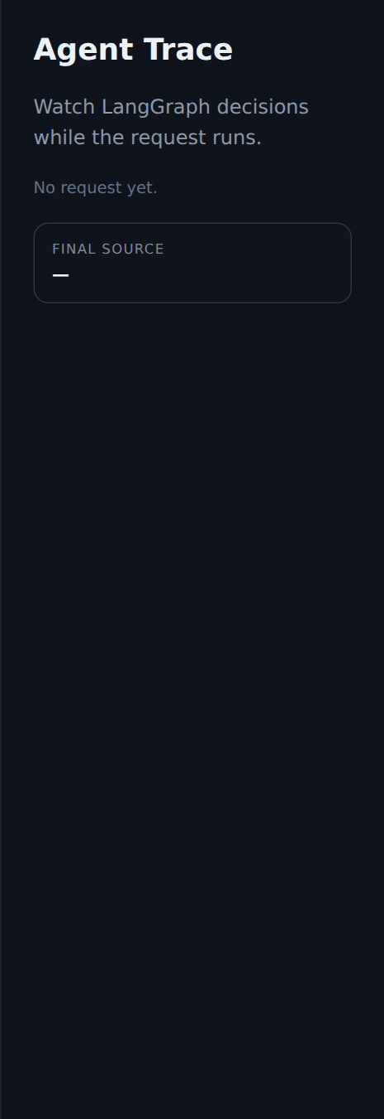  Agent Trace panel before a request
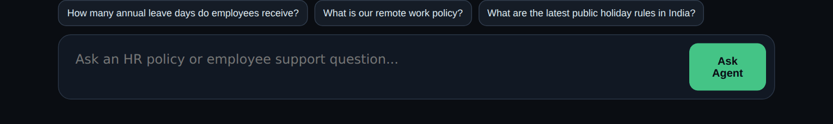
Example questions and the question box

Activity 6.6: Walk Through the Question Scenarios
Private knowledge base answer. The question "How many annual leave days do employees receive?" is answered from the company handbook. The trace shows the route to the KB, retrieval of 4 chunks, a GOOD evidence grade and answer generation from the private KB. The final source is private_kb.
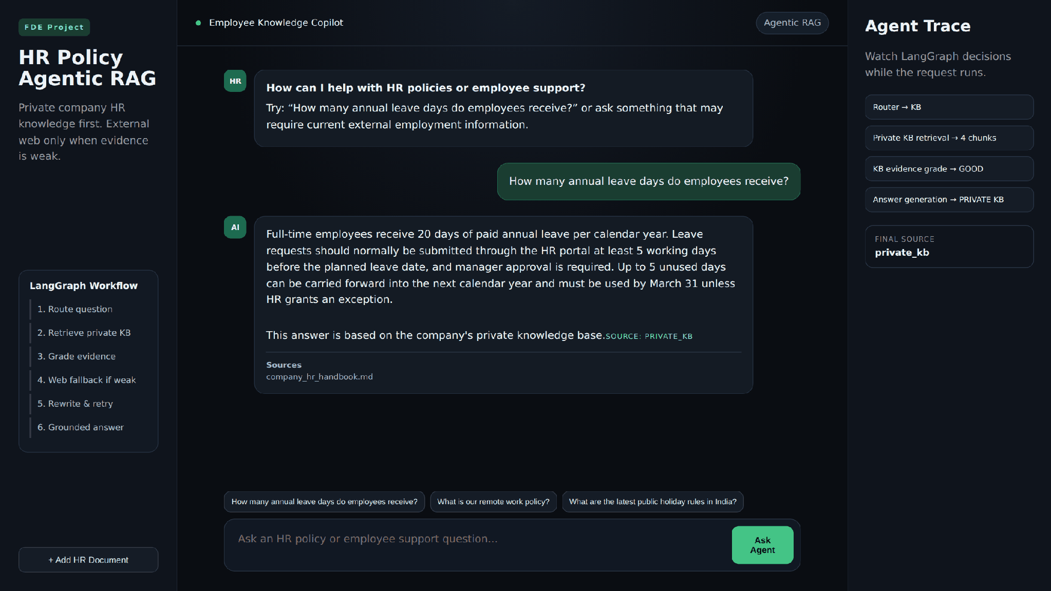
Scenario 1 — answer from the private knowledge base
Company policy question. The remote-work question is also answered from the handbook without any web search.
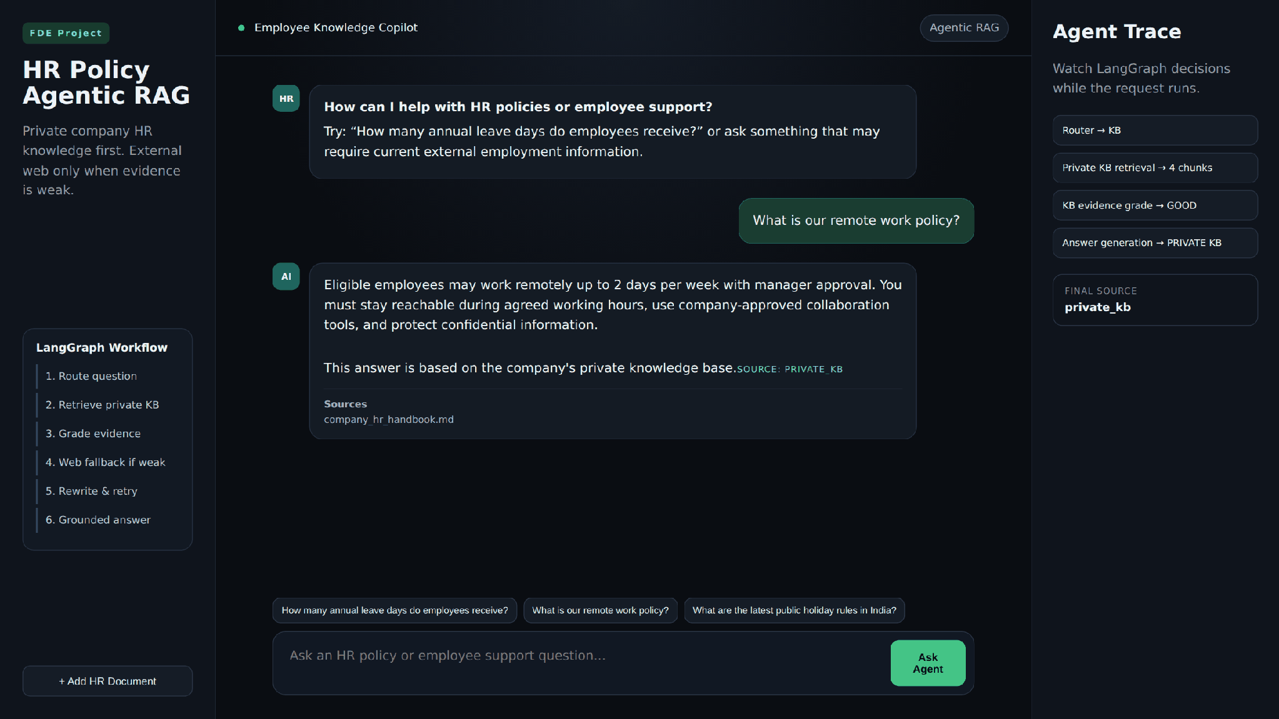
Scenario 2 — company policy question
External information fallback. For the public holiday question, the KB grade is WEAK, so the trace shows the Tavily search, a GOOD web grade and an answer generated from the web. The answer starts with a note that the information is external and may need HR validation, and the sources are listed as links.
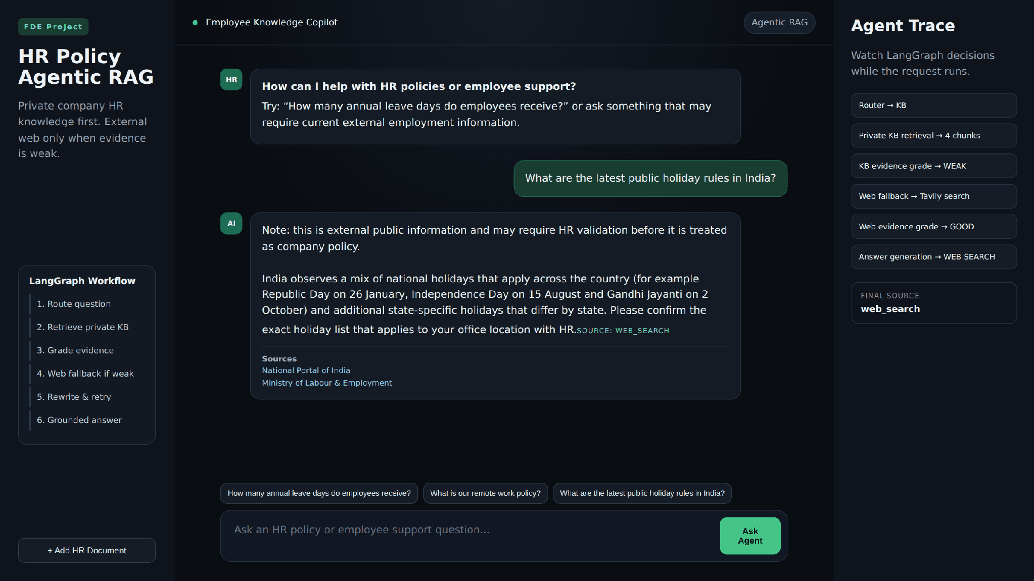
Scenario 3 — web fallback with citations
Query rewrite and insufficient evidence. For an ambiguous question, both grades are WEAK, the query is rewritten once, the retry also fails, and the agent stops with the safe message. The final source is insufficient_evidence.
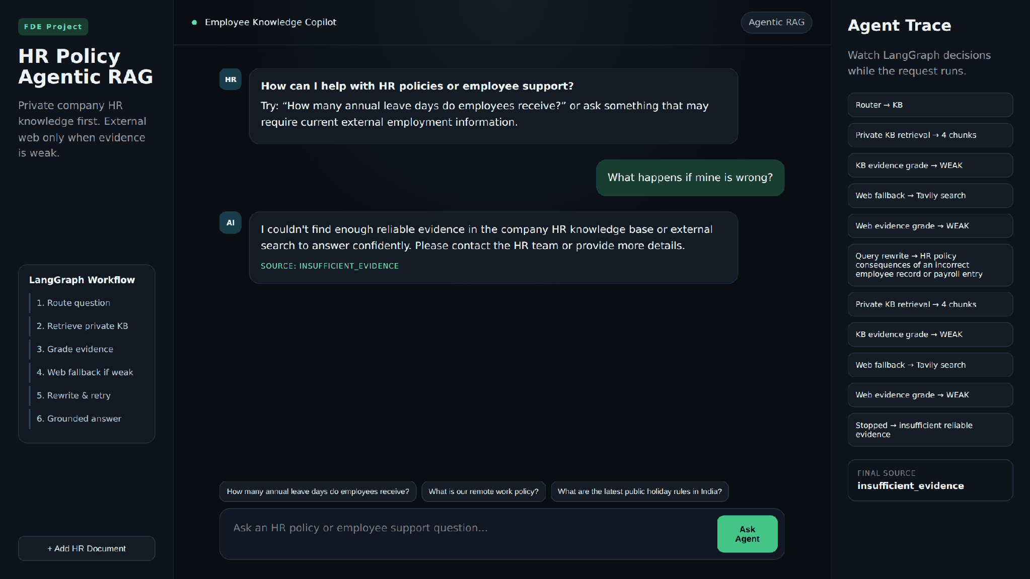
Scenarios 4 and 5 — rewrite, retry and safe stop
Document ingestion. Clicking "Add HR Document" opens the upload dialog. After entering the admin key and choosing a file, the interface shows how many chunks were indexed.
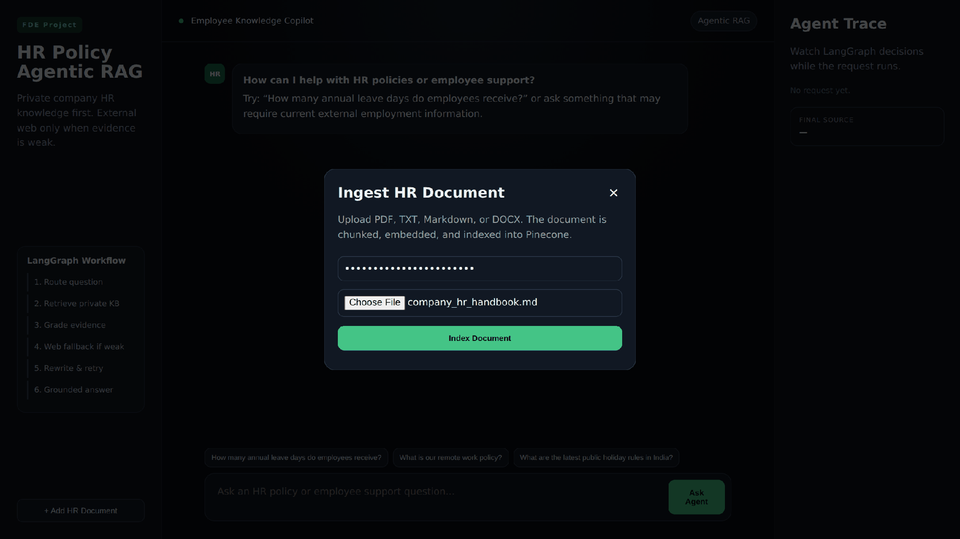  Dialog with admin key and file selected | 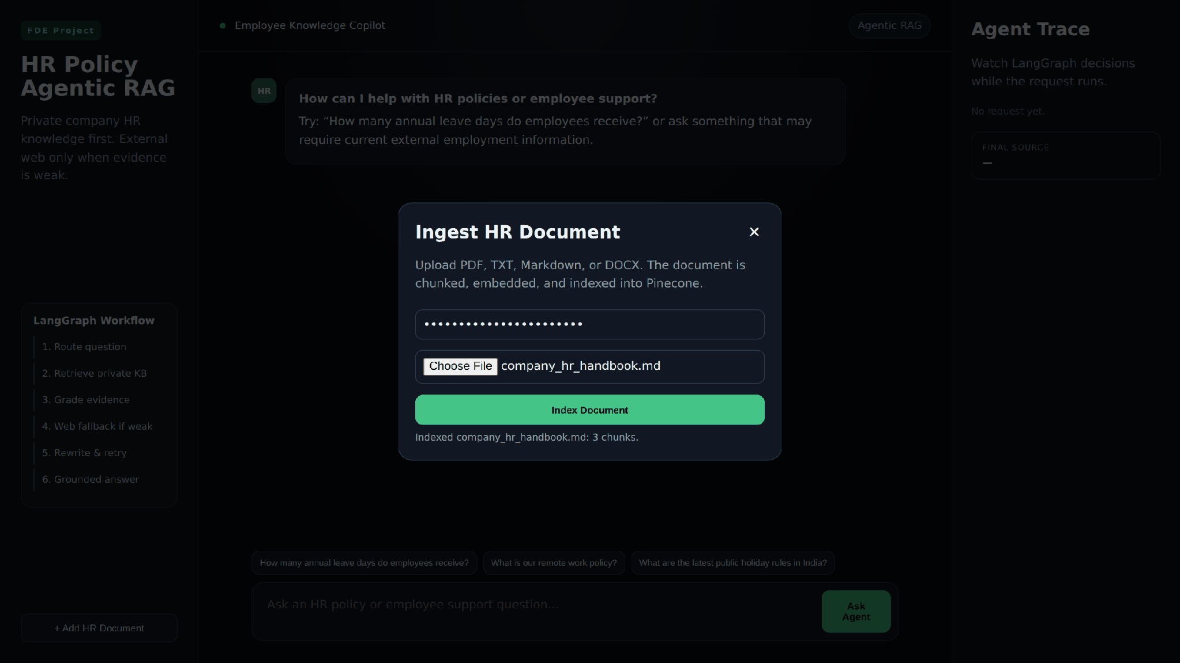  Indexing result
Note: the interface screenshots in this milestone were captured from the project's own index.html, style.css and app.js. The responses were simulated so that each path can be shown without live API keys; they follow exactly the response format and trace messages produced by the backend.

Milestone 7 — Testing, Containerisation and Deployment
Containerised the application with Docker, defined the test cases for validation, AI behaviour, ingestion, error handling and auditing, verified chunking and server startup, and documented the deployment on a DigitalOcean droplet.

Activity 7.1: Containerise the Application with Docker
The Dockerfile uses the lightweight python:3.11-slim image, disables bytecode files and output buffering, and sets the default port to 8080. The requirements file is copied and installed before the source code, so Docker reuses the cached dependency layer when only the application code changes. The container starts Uvicorn on 0.0.0.0 using the PORT variable with a default of 8080.
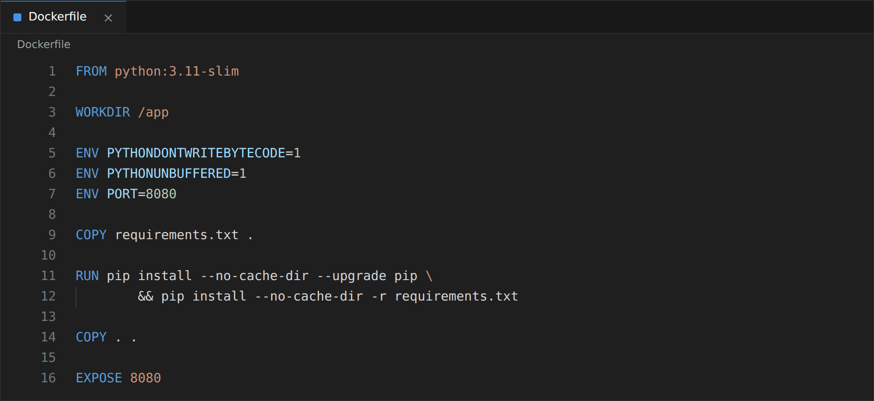

Activity 7.2: Exclude Unnecessary Files with .dockerignore
.dockerignore keeps the image small and safe. The .env file is excluded so that API keys are never baked into the image, and the Git folder, editor settings, virtual environments, Python cache files, test folder and log files are left out as well.
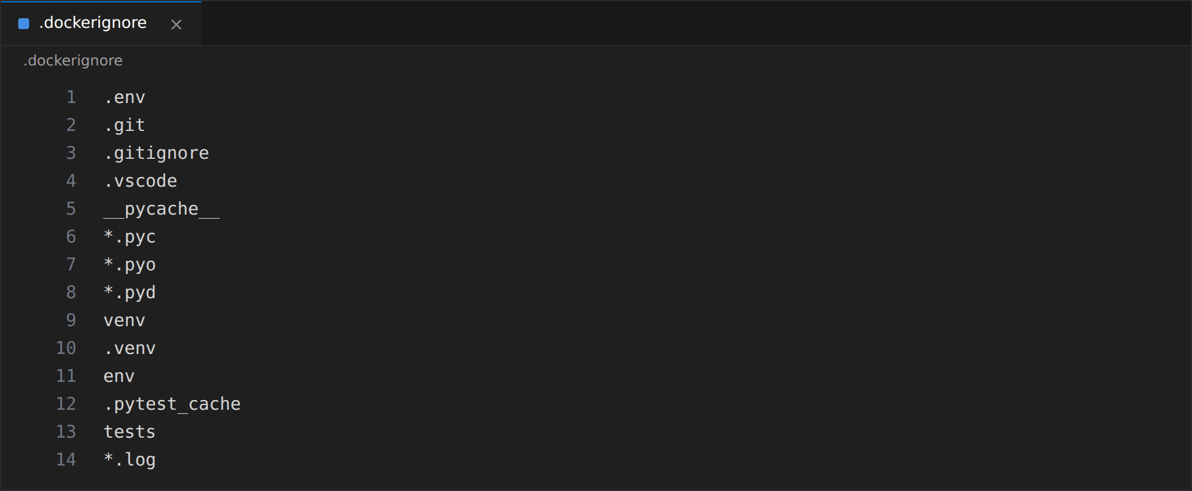

Activity 7.3: Build and Run the Container
The image is built with docker build. Because .env is not part of the image, the keys are supplied at run time with --env-file, and port 8080 is published so that the application is reachable at http://localhost:8080. The audit database is stored in the data folder inside the container, so a mounted volume should be used when the logs must survive container replacement.

Activity 7.5: Verify Chunking and Server Startup
The chunking test (TC-17) was executed against the sample handbook and printed 3 chunks, as shown in Milestone 2. The application server was also started with python run.py and the captured output (TC-01) confirms that Uvicorn watches the project directory for changes, runs on 127.0.0.1:8080, starts the server process and completes application startup without errors.
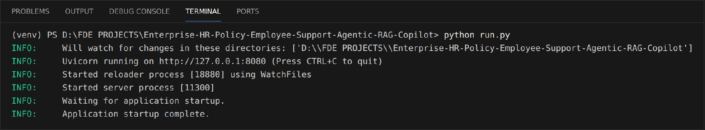

Conclusion:
Enterprise HR Copilot is an Agentic RAG system that answers HR policy questions from trusted company knowledge and falls back to external information only when the private evidence is not enough. LangGraph coordinates ten nodes that route the question, retrieve and grade evidence, search the web, rewrite weak queries, generate grounded answers and stop safely when the evidence is insufficient. Gemini performs the routing, grading, rewriting and answer generation, Pinecone with HuggingFace embeddings stores the private HR knowledge base, and Tavily supplies the web fallback.
FastAPI provides validated, documented endpoints for chat, health checks and protected document ingestion, while SQLite audit logging records each question, source and decision path. The HTML, CSS and JavaScript interface makes the agent's reasoning visible through the live trace and source citations, and Docker packaging on DigitalOcean makes the solution reproducible and ready for production use. Together, these parts reduce repetitive HR queries, give employees faster and more accurate answers, and keep every response transparent and traceable.

